**CHAPTER 3:**

**Population-specific responses determine species’ vulnerability to climate change: a spatiotemporal case study of *Pinus ponderosa***

Daniel L. Perret1, Margaret E. K. Evans2, 3, & Dov F. Sax1

1Dept. of Ecology, Evolution & Organismal Biology, Brown University, Providence RI

2Laboratory of Tree Ring Research, University of Arizona, Tucson AZ

3Dept. of Ecology & Evolutionary Biology, University of Arizona, Tucson AZ

In preparation for submission to *Global Change Biology*

**Abstract**

Forecasts of species’ climate change responses often make the simplifying assumptions that *(1)* all populations have the same climatic tolerances, and *(2)* those tolerances can be inferred from species-wide responses. These assumptions, which we collectively term the *shared response assumption*, underlie the use of climate envelope approaches for forecasting range dynamics. However, recent empirical work has shown that population-level climate responses can vary widely and even be opposite in sign to species-wide responses. Thus, the question is whether species’ fates in future climates will be determined by species-wide responses, as forecasted by climate envelope approaches, or locally differentiated population-level responses. Here we use tree-ring data to examine the consequences of contrasting species-wide and population climate responses, and test which better predicts observed growth responses to recent climate change. Using ponderosa pine as a model species and case study, we focus on 24 populations across the western US that have experienced varying degrees of warming over the past century. We divided growth time series data from each population into pre-warming (1900-1982) and post-warming (1983-2015) periods, defined empirically with breakpoint regression of climate time series data. We modeled pre-warming growth variation as a function of spatially-varying climate normals, capturing the species-wide response, and annually-varying seasonal climate, capturing population-specific responses. We used this model to *(1)* project post-1982 growth following species-wide versus population-specific responses through the end of the 21st century under future climate scenarios, and *(2)* compare predicted post-warming (1983-2015) growth to observed growth. Based on species-wide climate responses, growth increases of up to 200% were predicted across all populations, whereas population-specific climate responses predicated growth decreases of up to 75%. Observed post-warming growth correlated poorly with species-wide predictions, with correlations between predicted and observed growth trending increasingly negative at sites that experienced more warming. Taken together, our results indicate that trees have responded to recent warming according to population-specific climate sensitivities, and that future climate change impact projections that ignore these population-level processes will be increasingly wrong as the climate continues to change.

**Introduction**

Predicting how climate change will impact species, their distributions, and the ecosystems they comprise is a grand challenge for modern ecology (Thuiller 2007, Duarte 2014, Srivastava et al. 2021). Species distribution models and similar climate envelope approaches have been used to make the majority of these kinds of predictions (Araújo et al. 2019), typically relying on static associations between long-term average climate and a species’ geographic distribution to estimate the suitability of current and future climates. In so doing, climate envelope-based predictions make the simplifying assumptions that *(1)* all populations comprising the species will respond similarly to changing climate, and that *(2)* population-level climate responses can be inferred from species-wide associations with climate averages. These assumptions, which we collectively term the *shared response assumption*, are not met whenever populations are adapted to historical local climatic conditions. Local adaptation of this kind is common, especially among species with large or disjunct distributions that occupy a wide range of climatic conditions (Kawecki & Ebert 2004, Savolainen et al. 2007, Angert et al. 2011, Alberto et al. 2013, Valladares et al. 2014). When locally adapted climate responses exert stronger control over populations’ responses to climate change than species-wide associations with average climate, expected patterns like leading-edge/trailing-edge dynamics and poleward range shifts may not be realized (Pelini et al. 2009, Valladares et al. 2014, Herrando-Pérez et al. 2018, Peterson et al. 2018, Moran 2020). This is one potential reason for widespread mismatches between species’ forecasted and observed responses to climate change (Lenoir & Svenning 2015, Lenoir et al. 2020).

An emerging body of work has begun arguing that local adaptation should be incorporated into climate envelope-based predictions of species’ responses to climate change (Peterson et al. 2018). So far, attempts at this have approached the problem by modeling intraspecific variation in functional traits (*e.g.,* Benito Garzón 2019, Van Nuland et al. 2020), dividing species into subspecific groups (*e.g.,* Maguire et al. 2018, Chardon et al. 2020, Collart et al. 2021), and leveraging historical data from transplant experiments (*e.g.,* Prasad & Leites 2020, Midolo et al. 2021). However, empirical assessments of the mismatch between predictions made with and without the shared response assumption (*i.e.,* using species-wide versus population-specific climate responses) are rare (Adler et al. 2020, *but see* Renwick et al. 2017, Chardon et al. 2020). Further, while past studies have compared, for example, species distribution model predictions to observed population characteristics (*e.g.,* Beale et al. 2008, Woodin et al. 2013, Baer & Maron 2020, Midolo et al. 2021), none that we are aware of have also performed similar comparisons incorporating population-specific predictions. This is an important gap in our understanding, as population-specific climate responses that differ substantially from species-wide responses could result in large mismatches between these two forecasting approaches (Figure 1). In particular, some existing work has shown that population-level climate responses can indeed be opposite in sign to species-wide responses (Canham et al. 2018, Klesse et al. 2020). Given this possibility, it seems clear that the field of climate change biology would benefit from a better understanding of how dramatically species-wide and population-specific predictions can diverge.

These issues have not yet been resolved largely because datasets capable of addressing the multiple aspects of the problem are limited, even for well-studied model species. There are three data characteristics necessary to be able to parse species-wide and population-specific climate responses. First, the data must reflect how some aspect of a species’ performance (*e.g.,* growth, abundance, fecundity; McGill et al. 2006) responds to variation in climate over time. Longitudinal performance data is necessary to separate population-specific, temporal climate responses from the species-wide response to spatial variation in average climate (Adler et al. 2020). Second, the time period(s) captured by these performance data must include a sufficient range of natural historical climatic variation, as well as a directional climatic shift approaching those induced by recent climate change. Capturing both of these aspects of climate variation – a baseline and an emerging anthropogenically driven trend – is necessary both to separate a population’s response to recent climate change from background performance variation, as well as to have an observed response against which predictions can be compared. Finally, these data must come from multiple populations distributed throughout the geographic range and climatic niche of a wide-ranging ranging species, such that they capture the breadth of possible climate responses (Perret & Sax 2021).

Data that meet these criteria are obtainable for many temperate and boreal tree species. There is already considerable evidence for strong local adaptation to historical climatic conditions for some commercially important trees (*e.g.,* *Picea abies, Pinus ponderosa*, *P. contorta, P. sylvestris, Pseudotsuga menziesii*), due in part to a long history of common garden provenance trials used to discern suitable plantation seed stock (Veen 1954, Callahan 1962, Langlet 1971, Sork et al. 2013). Recent work has found that locally adapted climate responses in these species may already be playing a role in population declines as climate change pushes populations away from their local climatic performance optima (Aitken & Bemmels 2015, Midolo et al. 2021, O’Neill & Gómez-Pineda 2021, Prasad & Leites 2021). Further, the annual growth rings formed by many tree species constitute a longitudinal record of performance variation in response to annually-varying climatic conditions over the lifetime of an individual – up to several thousand years for some species (Piovesan & Biondi 2021). These tree-ring records can be easily sampled, providing rich ecological data with a rare temporal depth and resolution (Evans et al. 2021). Spatial networks of tree-ring data have already been used recently to show that tree growth responses to climate can differ between forest regions (Charney et al. 2016), between populations across a species’ range (Chen et al. 2010, Buechling et al. 2017, McCullough et al. 2017, Canham et al. 2018, Klesse et al. 2020), and even between demographic stages of a single species (Canham et al. 2016, Carroll et al. 2021). The advantages afforded by these data could best be leveraged if samples were collected from across a species’ geographic range and climatic niche, according to consistent protocols, and over a common time interval. While existing tree-ring data networks like the International Tree-Ring Data Bank are well-suited for addressing many questions in global change biology (Babst et al. 2018, Klesse et al. 2019), they often suffer from sampling and other biases that restrict the breadth of climate types they represent, thus limiting their utility for examining range-wide and niche-wide patterns (Zhao et al. 2018, Klesse et al. 2019, Perret & Sax 2021). Overcoming this barrier requires targeted field sampling that intentionally minimizes climatic biases in order to collect growth time series that are representative of the breadth of responses a species may exhibit.

Here we use a tree widely distributed across western North America - ponderosa pine (*Pinus ponderosa*) - as a case study to examine in detail the consequences of the shared response assumption for predicting species’ responses to climate change. Using a unique set of tree-ring data collected from across its geographic and climatic distribution, we model variation in ponderosa pine performance as a function of: *(1)* a species-wide response to spatially-varying climate normals, reflecting the shared response assumption common in climate envelope approaches, and *(2)* population-specific responses to time-varying seasonal climate variables, reflecting locally-differentiated climate tolerances. We first fit this model with data predating significant climate warming. We then use modeled species-wide and population-specific growth responses to tree growth rates over the time period of recent climate warming, and compare these predictions to observed growth responses over the same period. Finally, we use future climate projections to assess how widely species-wide and population-specific growth projections diverge over the 21st century.

**Methods**

Study species

We treat our study species, ponderosa pine (*Pinus ponderosa*), according to the most common taxonomic treatment and recognize two dominant varieties, var. *scopulorum* and var. *ponderosa* (Farjon & Filer 2008). Ponderosa pine *sensu lato* is widely distributed in western North America throughout a highly disjunct range that encompasses a tremendous breadth of climatic conditions, with mean annual temperatures ranging from 0 to 15 degrees Celsius and 200 to 2100 millimeters of mean annual cumulative precipitation (Figure 2). While recent molecular work has found evidence of more complex taxonomic structures within ponderosa pine (Willyard et al. 2017, Willyard et al. 2021), no work has yet demonstrated that subspecific taxonomic divisions align with consistent differences in climatic responses (McCullough et al. 2017, *but see* Maguire et al. 2018). The analyses we present here thus treat the species as a single unit, though future work should consider examining subspecific differences in climate responses as well.

Tree-ring data

*Data collection*

We selected study populations from across the distribution of ponderosa pine, following the niche-based methodology proposed by Perret & Sax (2021). We used curated and taxonomically-verified botanical records compiled in the Conifer Database (Farjon 2021) to bound the climate space occupied by ponderosa pine across its geographic distribution. This climate space was defined by a set of seven climatic variables previously used to model the climatic niches of pines and other conifer species (Perret et al. 2019, Perret & Sax 2021). We limited site selection to public lands managed by the United States Forest Service or the Bureau of Land Management. Further criteria were that sites were free of obvious recent disturbance (*e.g.,* timber harvest, thinning or other stand management, recent fire), were a minimum of one kilometer from high-traffic roadways, and were not located on either particularly steep slopes or along drainages. Wherever possible, we selected sites such that they corresponded with one of the Conifer Database botanical records used to build the species’ climatic niche model. This site selection procedure resulted in 24 study sites, spread across the states of Arizona, California, Colorado, Idaho, Montana, Oregon, and Montana (Figure 2, Table S1).

We used a consistent plot- and survey-based approach to collect tree-ring samples at each site identified by our niche-based sampling design. Specifically, we established a 25-meter by 25-meter square plot in a representative portion of the stand at each site. In this plot, we measured each ponderosa pine’s bole diameter (diameter at breast height; DBH), assessed its condition, recorded the presence or absence of new cones, and recorded any evidence of pathogens (*e.g.,* sap flows, needle blight). Using a Haglöf increment borer, we collected two 4.3 mm-diameter cores from each tree greater than 15 cm DBH in the plot. One core was collected at breast height (140 cm), and the other was collected as close to the ground as possible given available equipment and the individual tree’s setting. In cases where there were fewer than 15 suitable trees on a plot, we sampled additional trees at increasing distances from the plot center. For 10 sites, we could not establish a fixed plot due either to excessive understory growth or site terrain characteristics. For these sites, trees were sampled at increasing distances from the initially-intended plot location (*i.e.,* an n-tree sampling design; Lessard et al. 1994). Every site was visited during the 2018 growing season between June and October.

*Sample preparation*

All increment cores were mounted, sanded, and visually cross-dated according to standard dendrochronological methods (Speer 2009). We then measured the width in millimeters of each growth ring in every core sample using 2400 dpi digital scans and the computer program CooRecorder (Cybis 2021). We performed statistical dating checks on measured tree ring series using CDendro (Cybis 2021) and the ‘dplR’ package in R 3.6.3 (Bunn 2008, Bunn 2010, R Core Team 2021). Specifically, we used 20-year lagged inter-series correlations to identify dating and measurement errors across all series per site. These errors were iteratively identified and corrected until all inter-series correlations were above 0.60. Both core samples for each tree were used during visual and statistical cross-dating, but only samples extracted from breast height were retained for growth analyses. For one site, located outside of Show Low, Arizona, a high rate of missing and false rings prevented confident assignment of a year of formation to growth rings. This site was excluded from all subsequent analyses. We used field-measured DBH for each tree to convert these time series to annual basal area increments (BAI), a procedure that controls for the geometric trend of increasing tree bole diameter on annual ring widths (Phipps 2005). In total, this yielded 360 usable tree growth time series from 23 sites (Table S1).

Analyses

*Climate data*

We associated annual BAI time series for each tree at each site with PRISM LT81m historical monthly climate time series spanning the years 1900 – 2015. For each year, we summarized monthly climate data into eight seasonal periods spanning the growing season of the previous year through the end of the current year. In each of these seasons, we calculated mean maximum monthly temperature and cumulative precipitation. To characterize the general climatic regimes at each site, we calculated mean annual temperature and mean annual cumulative precipitation in 30-year moving windows, as well as across the length of the entire time series. These climatic variables are similar to those used in recent range-wide growth analyses for ponderosa pine and other species (McCullough et al. 2017, Klesse et al. 2018, Klesse et al. 2020). Exploratory analyses indicated that interannual growth was more strongly correlated with these seasonal climatic variables than annual climatic variables. Some analyses have also included composite measures of moisture availability like vapor pressure deficit (*e.g.,* Restaino et al. 2016, McCullough et al. 2017) or climatic moisture deficit (*e.g.,* Littlefield et al. 2020), usually derived from a combination of temperature and precipitation measurements. Though these composite variables can be quite informative, we opted to include only mean and maximum temperatures and cumulative precipitation to limit model complexity and ease interpretation.

Substantial climate change has already been reported across western North America over the past several decades (Skinner & Majorowicz 1999, Dobrowski et al. 2013, Abatzoglou & Williams 2016, Abatzoglou et al. 2020). In order to identify when warming began in the climate time series at each of our study sites, we used a breakpoint regression analysis to assess how secular trends in annual temperature anomalies relative to 1900-1950 means have changed across our entire time series (1900-2015). Temporal breakpoints identified by this analysis were used to divide growth and climate time series into “pre-warming” and “post-warming” periods in subsequent analyses. Breakpoint analyses were conducted using the ‘segmented’ package in R3.6.3 (Muggeo 2017, R Core Team 2021).

*Growth model*

We were interested in describing two aspects of growth variation in our dataset: *(1)* species-wide variation in average growth rate associated with spatially-varying climate normals, and *(2)* population-specific variation in annual growth associated with time-varying climatic variables. In order to do this, we used a hierarchical generalized linear mixed model implemented in a Bayesian framework to model annual BAI during the pre-warming period as a function of a tree’s size in the preceding year, spatially-varying climate normals, and time-varying seasonal climate variables:



(1)

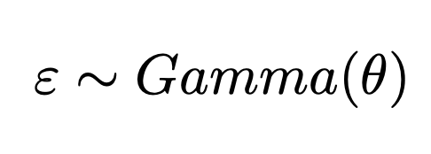

In this model, the BAI in year *y* of tree *t* at site *s* is modeled as the linear combination of that tree’s basal area (*BA*) in the year *y-1*, climate normals (*CN*) that vary between sites *s*, and annual climate variables (*TA, PA*) that vary between years *y* and sites *s*. **β** terms indicate estimated fixed effects describing species-wide responses, whereas **γ** terms indicate random effects varying across sites *s* or trees *t*. Hence, **β** is the species-wide intercept (average BAI), whereas **γ0,t,s** is a random modification of the species-wide intercept for each tree *t* nested in each site *s*. This random intercept modification accounts for growth variation between sites and between trees within a site caused by non-climatic factors like soil characteristics, topography, stand density, and disturbance histories. Basal area (*BA*) was back-calculated using field-measured DBH and ring widths, and standardized relative to the mean tree size at each site. Because the influence of tree size on BAI can vary widely, we included a site-level random slope modifier on this term (**γ1,s**). The index *i* varies from one to three, denoting one of two climate normal variables *CN*, mean annual temperature and mean annual precipitation, and their interaction. The **β** coefficients then capture the species-wide relationship between mean climatic conditions and BAI. The index *j* indicates one of eight seasonal periods ranging from the previous year’s growing season through the end of the current growing season in year *y*. Thus, the parameters **β3j** and **β4j** describe the fixed species-wide effect of mean monthly maximum temperatures (*TA*) and cumulative precipitation (*PA*), respectively, during each period *j*. The parameters **γ2j** and **γ3j** capture population-specific deviations from the species-level response to each of the same seasonal predictors. Because growth increments are always greater than zero, with a variance proportional to the mean, we used a Gamma distribution with a logarithmic link function and an estimated dispersion parameter θ to describe the model error distribution. To accommodate this link function, we added the minimum observed ring width in each series to any missing rings in that series (*i.e.,* years that were identified via cross-dating, but where no growth was recorded).

Past work has indicated that population-specific growth sensitivities to annual climatic variation can vary predictably with mean climatic conditions at a site (McCullough et al 2017, Klesse et al 2020). Interaction terms between climate normals *CN* and annual climatic variables *TA* and *PA* could be used to describe these patterns. However, because we were interested in separating species-wide and population-level responses, we opted to instead account for population-specific climate sensitivities by incorporating site-level random slope modifiers **γ2j** and **γ3j**. In addition, recent work has questioned the assumption of stationarity in climate responses through time that underlies a substantial portion of the dendrochronological literature (Astigarraga et al. 2020, Peltier & Ogle 2020, Wilmking et al. 2020, Keen et al. 2021). Because this work indicates that the climate sensitivities of a single tree can change through time as climate changes, we fit our model using only climate and growth data from the pre-warming period identified in our exploratory analyses of climate timeseries.

The high dimensionality of these random effects (**γ** terms) in our growth model made it difficult to obtain stable coefficient estimates using traditional frequentist methods. To address this, we implemented the growth model in a Bayesian framework with minimally-informative priors using the ‘brms’ package in R 3.3.0 (Bürnker 2018, R Core Team 2021). We assessed model convergence using R-hat statistics for the posterior distribution of each parameter estimate, and model fit by comparing the distribution of the training data to the distribution of the mean posterior predictions of those observations, across the entire dataset and by each site individually.

*Near-past retrodictions*

To examine whether observed growth better matched predictions derived from species-wide or population-specific responses, we predicted growth at each site in response to observed climatic conditions after the onset of warming. These predictions were made based on species-wide versus population-specific responses separately. Specifically, for species-wide responses, observed 30-year rolling mean climate normals in the post-warming period were entered into the model *CN* terms, while setting all other climate effects at zero, such that the predicted effect of changing climate depended upon the estimated values of **β**. For population-specific responses, observed post-warming seasonal climate values were substituted into *TA* and *PA* terms, while keeping all other climate effects at zero, such that the predicted effect of changing climate depended upon the estimated values of **β3j**, **β4j**,**γ2j**, and **γ3j**. For these post-warming predictions, we used observed tree sizes *BA* so that model predictions could be directly compared to actual growth observations. We compared post-warming predicted growth to observed growth by calculating the Pearson’s correlation coefficient of the observed and predicted growth series for each tree in the dataset. For species-wide predictions, we converted observed growth series to 30-year rolling means to match the scale of variability in the predicted series.

*Future projections*

We next applied the growth model to project future tree growth using climate projections from the CMIP5 multi-model ensemble dataset. Specifically, we downloaded 23 BCSD monthly climate and hydrology model variants (Reclamation 2013, Reclamation 2014) from the Downscaled CMIP5 Climate and Hydrology Projections archive (<http://gdo-dcp.ucllnl.org/downscaled_cmip_projections/>). We averaged across all model variants, and summarized monthly climate projections to recreate the mean, annual, and seasonal climate variables used in fitting the growth model (Equation 1). We used these future climate data to project growth through the end of the 21st century for each tree according to species-wide and population-specific responses to climate variation separately, as described above. To make species-wide growth projections, we substituted 30-year mean annual temperature and precipitation projections into the *CN* term in our growth model, while setting the effects of annual climate variables *TA* and *PA* to zero. For population-specific projections, we set the effects of *CN* model terms to zero, and substituted in projected future *TA* and *PA* variables. Both projection types were made with all modeled random effects, with tree size *BA* set to the mean observed value in the model fitting period. All model predictions were made using 2000 posterior draws, from which we retained mean posterior predictions and 95% credible intervals.

**Results**

*Secular climate warming*

Our breakpoint analysis of temporal trends in mean annual temperature anomalies between 1900 and 2015 identified the year 1983 as a significant breakpoint. After 1983, temperatures began warming at a significantly faster rate than prior (0.03oC year-1, p<0.001; Figure S1). This breakpoint forms the boundary between “pre-warming” and “post-warming” periods in all subsequent analyses.

*Observed and modeled growth*

Generally speaking, we found that trees grew fastest in warmer and wetter climates (Figure 2). Our fastest-growing population was found in the western Sierra Nevada foothills, where sampled trees accrued an average of more than 6500 mm2 of basal area annually. Our slowest-growing population was in eastern Montana, where trees were restricted to sheltered draws and accrued barely 600 mm2 of basal area annually. These sites bracketed a very large range of climatic conditions, from a mean annual temperature of 13oC with ~1300 mm of annual precipitation on the fast-growing end, down to 6.5oC and ~300 mm of precipitation in slow-growing sites. Interannual growth variation was negatively associated with mean growth rate, such that the coefficient of variation of annual growth was highest in slow-growing populations (Figure S2). This variation in interannual growth reflected a range of population-specific interannual climate sensitivities. Annual growth responses to interannual temperature variation ranged from weakly positive to strongly negative, often opposing the species-wide temperature response (Figure 2c). Annual growth responses to precipitation, on the other hand, were mostly positive (Figure 2d).

Our growth model converged over 2000 iterations and three Markov chains. Variance decomposition of the full conditional model (*i.e.,* including all random effects) yielded an *R*2 of 0.819 (95% CI: 0.813 – 0.824), whereas the marginal model (*i.e.,* including only fixed effects) had an *R*2 of 0.365 (95% CI: 0.190 – 0.552). The *R2* we report here was calculated as the ratio of the explained variance to the sum of explained and residual variance (Gelman et al. 2019). Model fit varied substantially between sampling sites (Figure S3, Figure S4), reflecting both variation in climate sensitivities between populations, as well as the high variance proportion contained in the model’s random effects. Mean annual temperature and mean annual precipitation (*CN*) both had strong positive effects on growth, reflecting observed patterns of faster growth in warmer and wetter regions (Figure 3a-b). The posterior coefficient estimates for mean annual temperature and mean annual precipitation were 0.45 (95% CI: 0.26 – 0.65) and 0.29 (95% CI: 0.07 – 0.51), respectively. Because climate normals were scaled between sites prior to model fitting, these coefficient estimates should not be compared directly to those for seasonal climate variables, which were scaled locally. Seasonal climatic variables had a wider range of effects, with differences between sites dependent on seasonal period and climatic variable (Figure 3c-d). Maximum temperature (*TA*) effects were largely negative for most sites, except in winter (December – February) and spring (March – April) seasons. Seasonal cumulative precipitation (*PA*) effects were mostly positive, and largest from the winter through the early growing season (December – June).

*Near-past retrodictions*

Post-warming (1980-2015) growth predictions diverged when made with species-wide (*i.e.,* climate normals) versus population-specific (*i.e.,* annually-varying seasonal climate) responses (Figure 4). Species-wide responses predicted growth increases in all but four sites, ranging from a 7% to more than 130% increase by the end of the period (Figure S5). Population-specific predictions were more equivocal, with mean responses ranging from a 6% reduction to a 13% increase in growth. Observed growth matched population-specific predictions more closely than species-wide predictions (Figure 4), though we also found considerable variation between sites (Figure S5). Three sites had mean observed growth lower than that predicted by either response. A further three sites had mean observed growth higher than that predicted by either response, with two of these showing evidence of a growth release during the prediction period (Figure S5). Correlations between observed and predicted responses were mostly positive for predictions generated from population-specific climate responses. The correlation between observed and species-wide predicted growth, however, was often negative and had a significant negative relationship with the amount of climate warming that a site experienced during the prediction period (*r* = -0.42, *p* = 0.04; Figure 4).

*Future projections*

Future growth projections indicated that species-wide and population-specific responses continue to diverge. Using the species-wide climate response, we projected positive future growth trends through the end of the 21st century under an RCP 8.5 emissions scenario, with a median growth increase of ~75% over pre-1980 levels (Figure 5). Population-specific climate responses, on the other hand, yielded negative projected growth trends over the same period, with a median growth decrease of ~25% over pre-1980 levels (Figure 5). Species-wide projections varied according to the amount of projected climate change experienced by a population. Population-specific growth projections, however, varied much more widely between populations according to their specific climate sensitivities (Figure 3, Figure 5). Population-specific growth projections were positive for four populations, though the magnitudes of two of these were near zero (indicating little growth change relative to pre-1980 growth rates). Projected declines did not vary predictably across *P. ponderosa*’s range or climatic niche, with some of the largest declines projected in niche-central populations (Figure 5).

**Discussion**

Our results indicate that the shared response assumption can result in misleading predictions of species’ responses to climate change. Predicting recent growth since the onset of significant anthropogenic climate change demonstrated that species-wide and population-specific predictions can begin diverging after even just a few decades (Figure 4). Comparing these predictions to observed growth trends suggested that trees have responded to recent climate change according to population-specific patterns. When made using the shared response assumption, on the other hand, the likelihood that a prediction would be directionally (*i.e.,* negative correlation with observed growth) increased with the amount of warming that a site had experienced (Figure 4). These mismatches will only continue to grow though the next century (Figure 5). Taken together, these results indicate that trees have responded to recent warming according to population-specific climate sensitivities, and that future projections ignoring these population patterns and processes will be increasingly wrong as the climate continues to change.

The degree to which trees will continue responding to climate change in ways that can be reliably predicted from local responses to past climatic variation depends on the speed and strength of processes like acclimation, migration, and adaptation (Adler et al. 2020). It is useful to bracket the possibilities by considering the case where these processes do not occur at all, as well as the case where they occur instantaneously. In the absence of any acclimation or adaptation to changing climatic conditions, we should expect that trees will continue to respond according to their past climate sensitivities indefinitely. This is the scenario we play out in our population-specific future growth projections (Figure 4), and is a restatement of the ‘uniformitarian principle’ as it applies to dendrochronology (*i.e.,* that tree growth responses to climate are stationary through time; Peltier & Ogle 2020). However, evidence has recently begun to accumulate suggesting that climate-growth relationships can indeed shift through time (Astigarraga et al. 2020, Peltier & Ogle 2020, Wilmking et al. 2020, Keen et al. 2021). Whether these relationships can shift fast enough to buffer individual trees and populations from negative growth impacts of climate change is still unclear, however (Klesse et al. 2020). The other extreme case, in which acclimation is instantaneous, is consistent with the shared response assumption common in climate envelope models and approaches. This is the scenario we play out in our species-wide future growth projections, wherein a population experiencing warming temperatures will grow at a rate similar to a population in a warmer region that experienced those conditions in the past (Figure 4). Our results demonstrate that this scenario is unrealistic for tree populations on decadal timescales. Testing this scenario on longer timescales, or using species with faster generation times, may help resolve this uncertainty about whether populations can eventually acclimate enough to match these projections (Adler et al. 2020, Felton et al. 2021).

Our findings here are further contextualized by an additional body of work challenging the broad application of climate envelope approaches to predict various properties of populations. For example, recent work has demonstrated that habitat suitability, as estimated by a species distribution model, often fails to predict actual population abundance (Dallas & Hastings 2018, Santini et al. 2018, Jiménez-Valverde et al. 2020). This suggests problems with the theoretical underpinnings of the climate envelope approach, namely that species’ climatic performance optimums are located in the center of their climatic niches (Maguire 1973, Brown 1984, Santini et al. 2018). Explanations for these mismatches have included disequilibrium in species’ distributions, variation in how climatic conditions map onto the landscape, and population density dependence (Osorio-Olvera et al. 2019, Holt 2020). However, similar studies have also demonstrated that climate envelope approaches often fail to reflect other demographic processes as well (Beale et al. 2008, McGill 2012, Woodin et al. 2013, Baer & Maron 2020, Midolo et al. 2021, *but see* Green et al. 2008, Araujo et al. 2009). Notably, Midolo et al. (2021) found no consistent relationship between coarse-scale environmental suitability, as estimated by species distribution models, and individual fitness proxies derived from field measurements and common garden trials across 66 North American tree species, including ponderosa pine (Midolo et al. 2021). The analyses we present here advance this line of evidence by leveraging the temporal depth and resolution of tree-ring data to show that climate envelope approaches, and the shared response assumption in particular, are insufficient for reliably predicting tree growth responses to climate change.

There are additional non-climatic controls on tree growth that we do not explore in our analyses, but which may play a major role in shaping tree populations in the future. Cook’s (1987) linear aggregate model described tree growth as the sum of the effects of tree size, climatic factors, and exogeneous (*i.e.,* arising from external processes) and endogenous (*i.e.,* arising from characteristics of the forest stand) disturbances (Cook 1987). In our growth model, both types of disturbances are coarsely accounted for by site and tree-level random intercepts (Klesse et al. 2020). However, disturbance can modulate growth in complex ways that cannot be completely captured so simply. Exogeneous disturbance processes in particular will likely be increasingly important as changing climates alter fire regimes (Enright et al. 2015, Abatzoglou & Williams 2016), promote insect and pathogen outbreaks (Garrett et al. 2009), and increase the frequency of extreme weather events (Trouet et al. 2018). At least three of our study sites showed evidence of a growth release during the 1980-2015 retrodiction period that could have been caused by disturbance event of some sort (Figure S5). Individual disturbance events can temporarily decouple tree growth responses from climatic drivers (Peltier & Ogle 2020), while the frequency and intensity of these events describe disturbance regimes that can shape species’ distributions on the landscape (Schultz et al. 2021). Endogenous disturbances like inter- and intra-specific competition and stand dynamics can have similarly complex effects on tree growth rates (Cook 1987, Anderegg & HilleRisLambers 2019, Rollinson et al. 2021). Disentangling the interacting effects of climate and disturbance on tree growth and demography is thus a critical next step toward dynamically forecasting tree species’ responses to climate change.

Of course, growth is only one aspect of a species’ performance (*sensu* McGill et al. 2006), and our tree-ring data only reflect the climate response of that single aspect. While individual growth does have a long history of being used as a performance metric and fitness proxy (Lampert & Trubetskova 1996, McGill 2012), higher growth does not necessarily confer higher fitness (Silvertown 1993, Franco & Silvertown 2004), especially when comparing between populations. Widespread trade-offs between growth and survival (Sebastian-Azcona et al. 2019, Kunstler et al. 2020, Piovesan & Biondi 2021, Schultz et al. 2021), as well as between growth and fecundity (Drobyshev et al. 2010, Hacket-Pain et al. 2015, Clark et al. 2021), make the fitness impact of individual growth unclear. As a result, we are unable to confidently assign any adaptive value to the differences in climate-growth responses we found between populations. There are, however, other compelling reasons to focus on individual growth rates. For example, individual growth is a critical component of larger demographic processes in size-structured populations like trees (Silvertown 1993). Further, minor differences in growth rates can translate to much larger differences in the role forests play in regulating global chemical cycles, including carbon sequestration and storage (Pan et al. 2011, Giebink 2021).

Though the work we present is a single-species case study, there are aspects of our results that we believe are broadly informative. First, mismatches between species-wide and population-specific climate response have been found in several other tree species, including Douglas fir (*Pseudotsuga menziesii*; Klesse et al. 2020), which occupies a similar distribution as ponderosa pine. Similarly, Canham et al. (2018) found widespread mismatches between regional responses to mean climatic conditions and population responses to interannual climatic variation in 14 tree species in the eastern United States. If these sorts of mismatches are common, as they appear to be, then the shared response assumption may be problematic for many species. Second, the rate with which populations acclimate to changing climates has been shown to be one of the major sources of uncertainty in longer-term predictions (Adler et al. 2020, Felton et al. 2021). Our results put a lower bound on this uncertainty by demonstrating that trees have continued to follow population-specific climate responses through 35 years of climate change, suggesting that acclimation may require longer timescales. Finally, our results suggest that linking broad-scale macroecological patterns with local population-scale processes is critical for advancing our understanding of how species will respond in a changing world.

**Figures**

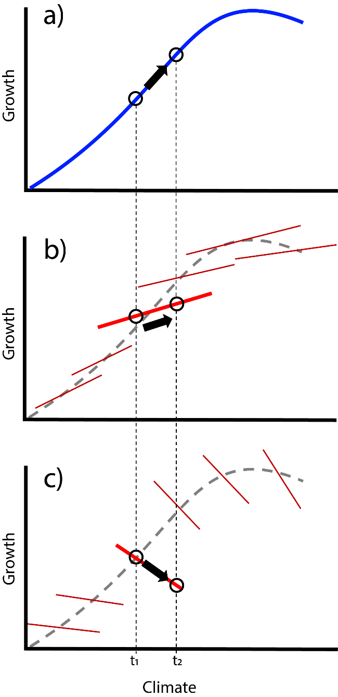

**Figure 1.** Conceptual diagram showing how species-wide **(a)** and population-specific **(b-c)** growth responses to climatic variation may yield different predictions when conditions change between time *t1* and time *t2*. In panel **(a)**, the relationship between climate and growth is described across the whole range of conditions occupied by the species (blue line). In panels **(b)** and **(c)**, these relationships are described for each population separately according to the local growth response to past climatic variation (red lines). In panel **(b)**, population-specific responses match the species-wide response in sign, but not in slope; in panel **(c)**, population-specific responses have the opposite sign as the species-wide response. Climate change between time *t1* and time *t2* would result in a large increase in growth according to the species-wide response **(a)**, a moderate growth increase in **(b)**, and a growth decline in **(c)**.

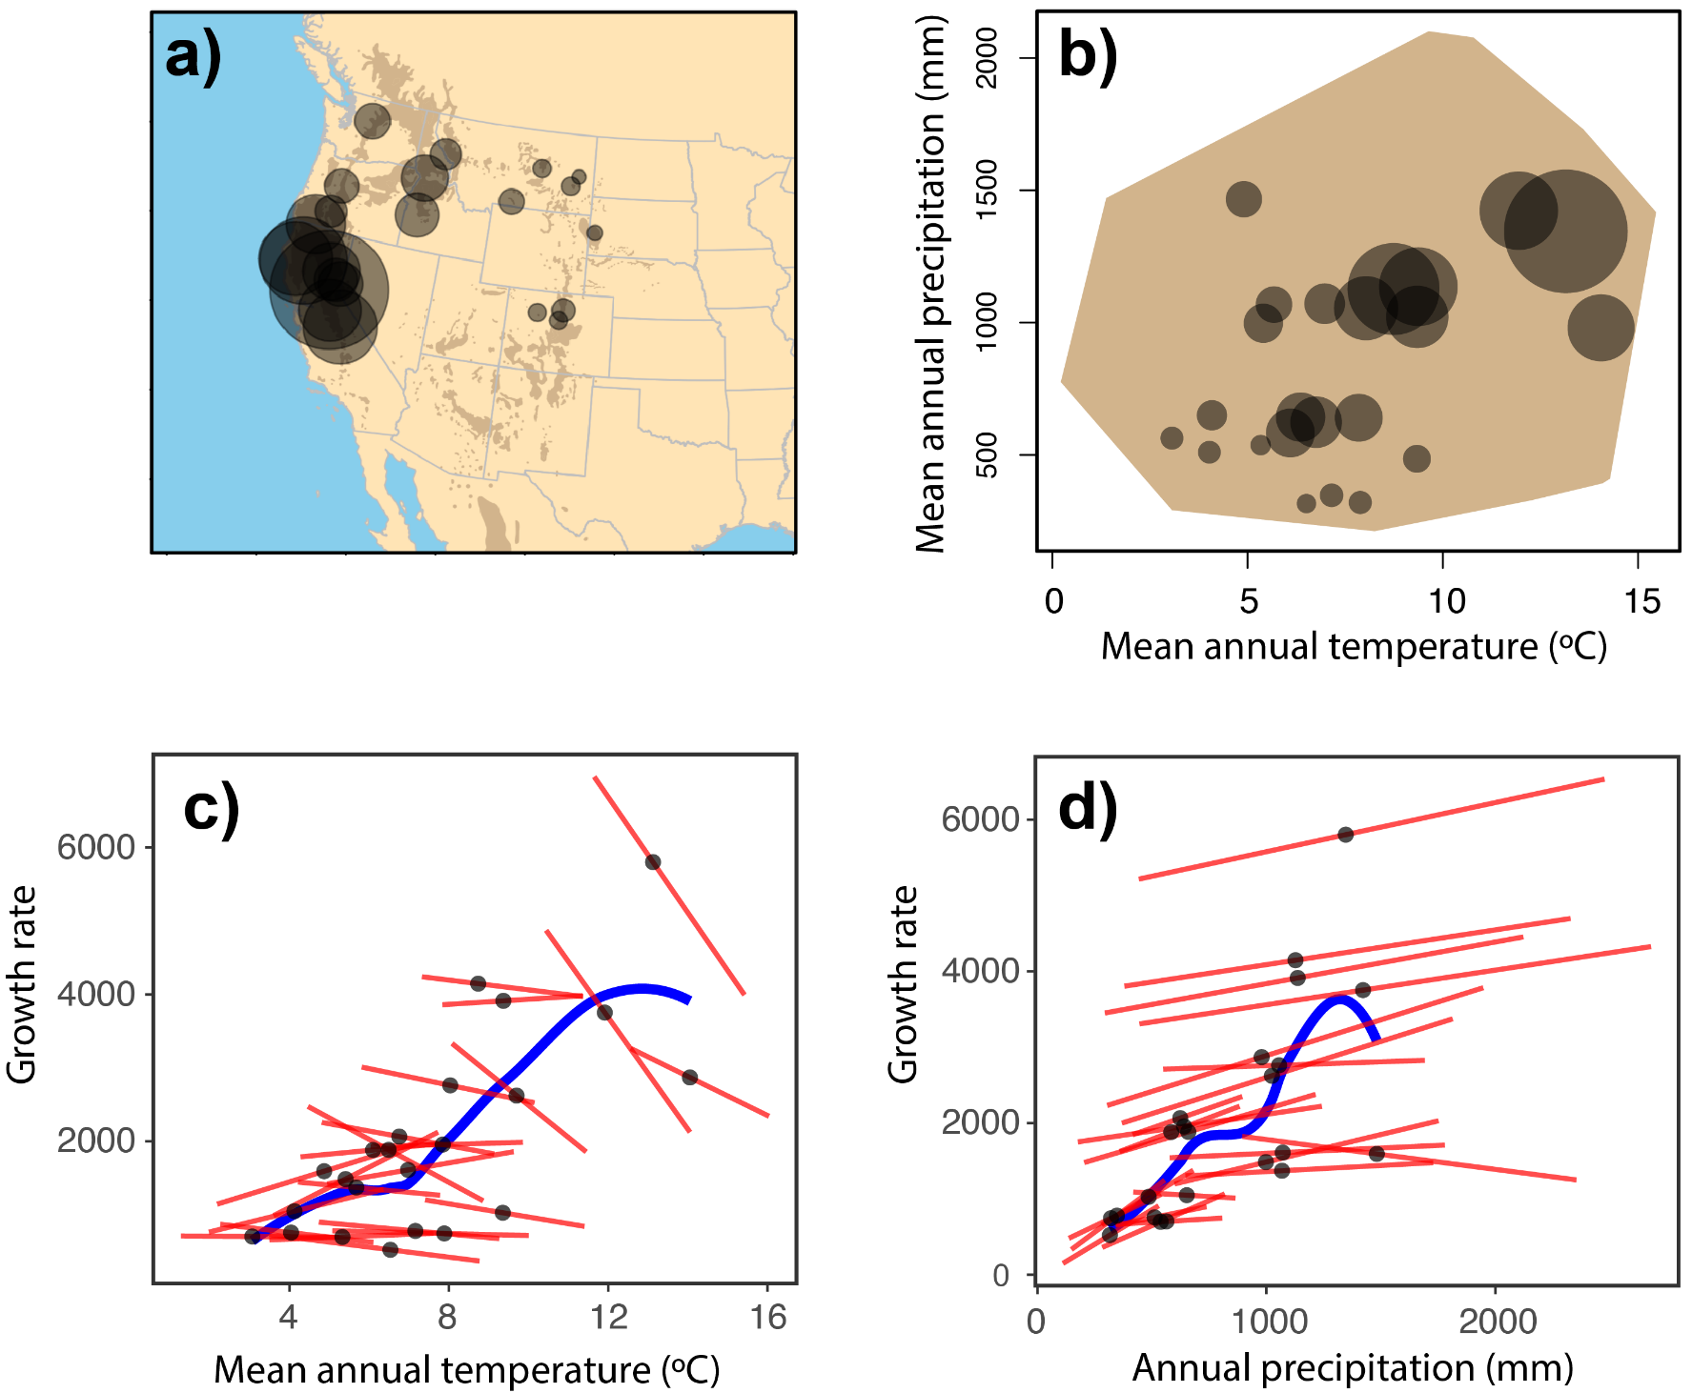

**Figure 2.** Variation in observed growth rates across *P. ponderosa*’s geographic distribution **(a)**, climatic niche **(b)**, and relative to mean annual temperatures and annual precipitation (**c – d**). In panels **(a)** and **(b)**, point size is scaled proportionally to the mean basal area increment across all trees in a site, with large points indicating fast growth and small points indicating slow growth. In panels **(c)** and **(d)**, black points indicate mean climatic conditions (x-axes) and growth rates (y-axes; basal area increment in mm2) at each site from 1900-2015. Blue lines are locally-weighted regressions through those points, showing the species-wide relationship between growth rates and mean annual temperature (**c)**, and mean annual precipitation **(d)**. Red lines in (**c)** and **(d)** correspond to population-specific climate sensitivities, and show the linear relationship between annually-varying mean annual temperature and annual precipitation and annual growth at each site.

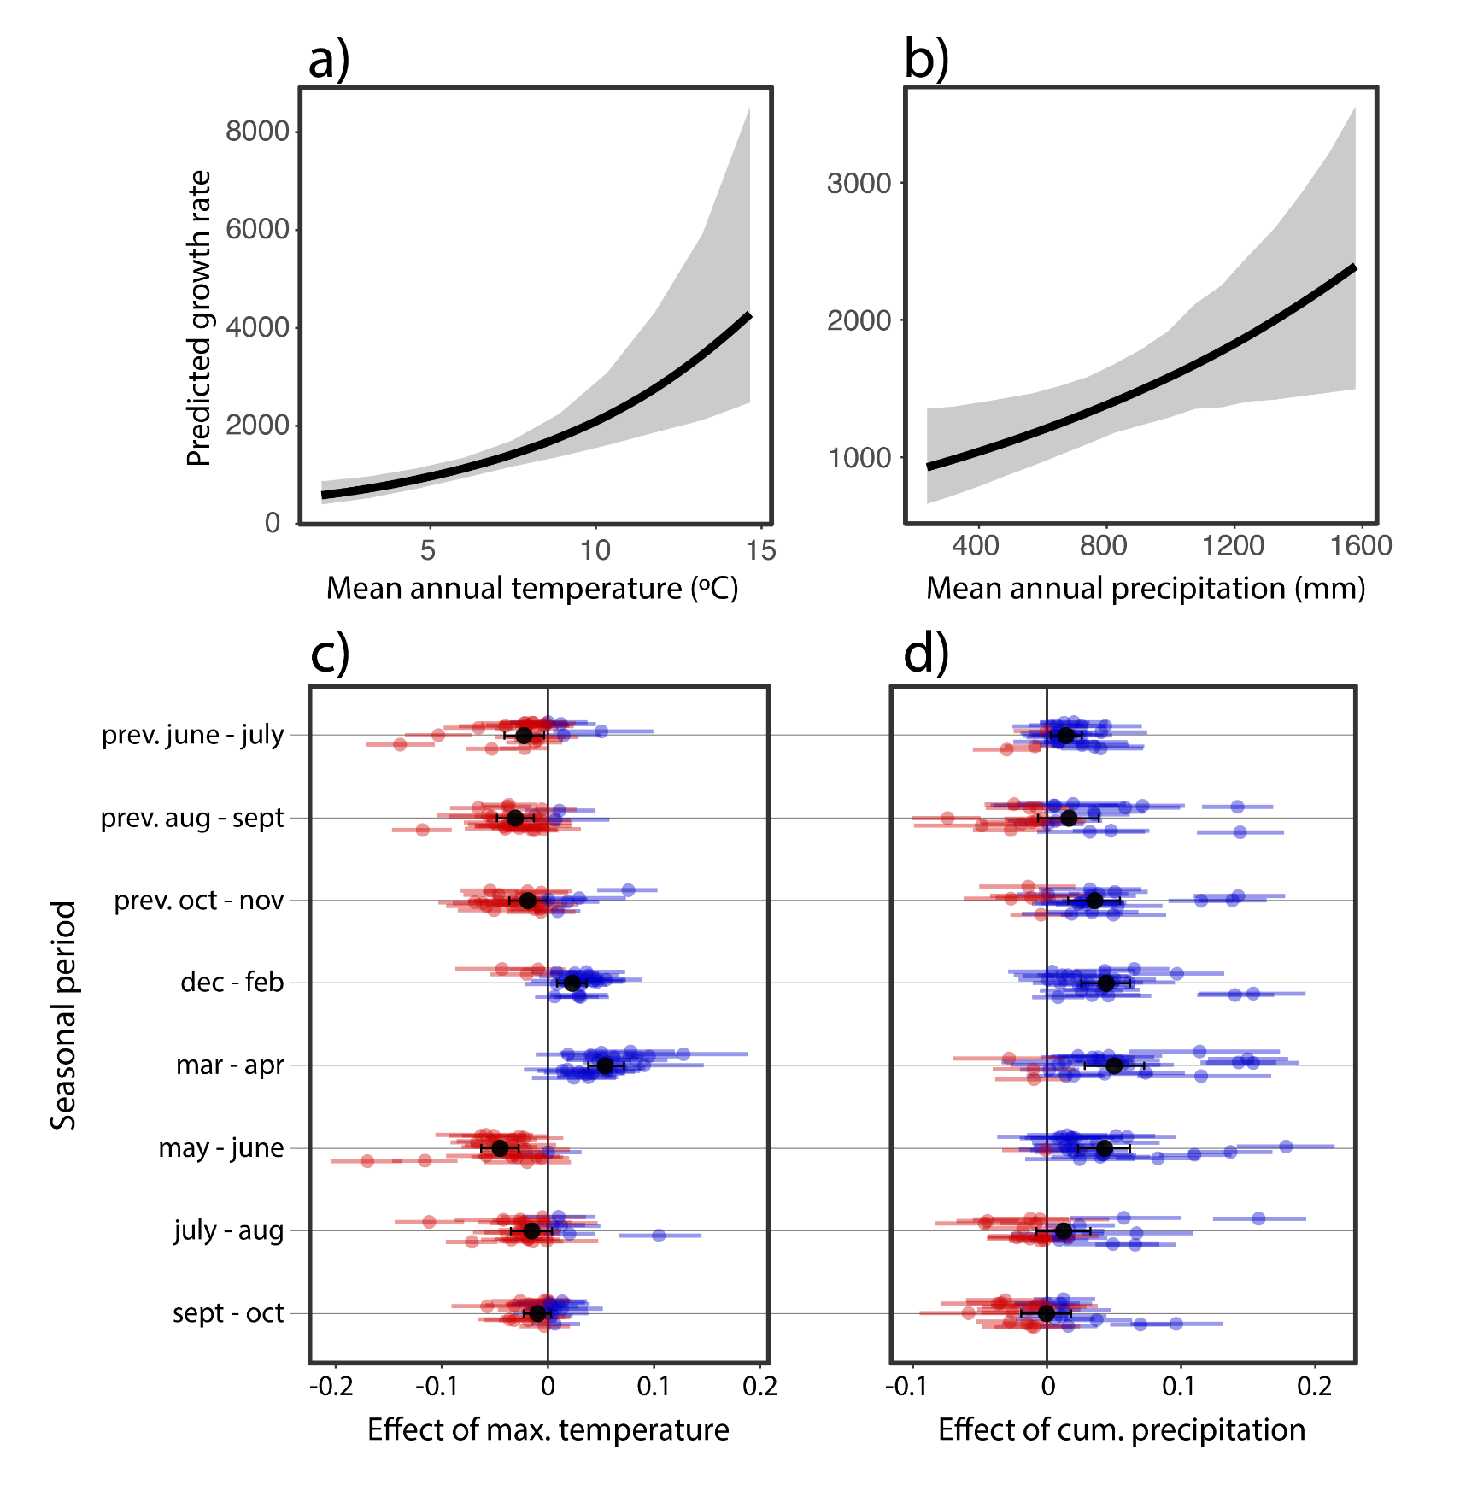

**Figure 3.** Modeled effects of climate normals and seasonal climate on tree growth. Panels **(a)** and **(b)** show the mean estimated marginal effects (black line) and 95% credible intervals (gray shading) of mean annual temperature **(a)** and mean annual precipitation **(b)** on basal area increment, corresponding with species-wide growth responses to climate. Panels **(c)** and **(d)** show the effects of maximum temperature **(c)** and cumulative precipitation **(d)** in each of eight annual seasonal periods (y-axes) ranging from the previous year’s growing season through the end of the current year. Effects shown (x-axes) are population-specific mean posterior coefficient estimates (points) and 95% credible intervals (lines). Black dots and bars indicate fixed effect estimates, whereas colored dots and lines indicate population-level random effects, with red indicating a negative mean posterior estimate, and blue indicating a positive mean estimate.

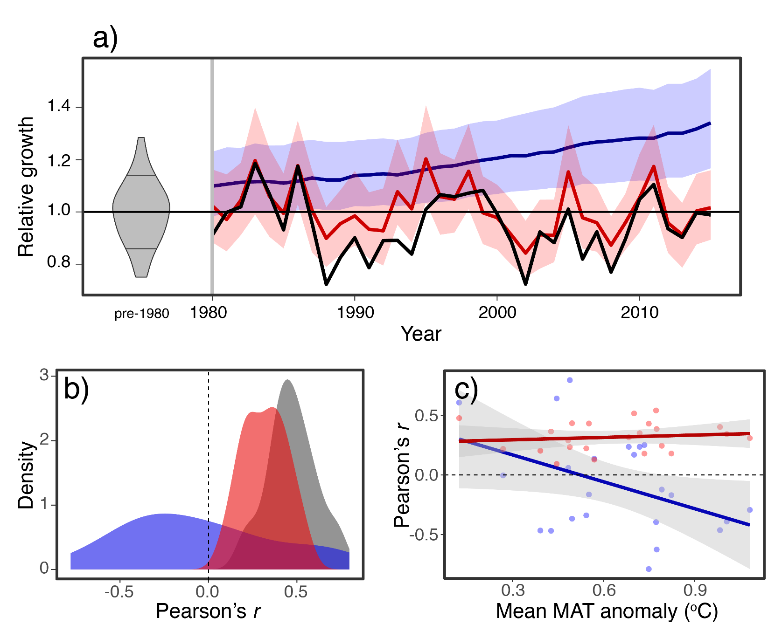 **Figure 4.** Observed and predicted growth from 1980 to 2015. Panel **(a)** shows growth relative to pre-1980 mean growth across all sites, according to modeled species-wide (blue line and shading), modeled population-specific (red line and shading), and observed (black line) responses. Annual median responses across all sites are shown with 95% credible intervals. Gray density plot shows the distribution of annual median relative growth in the pre-1980 period. Panel **(b)** shows the distribution of Pearson’s correlation coefficients calculated between each individual tree’s observed growth and growth predicted according to species-wide (blue area) and population-specific (red area) responses. The gray area shows the distribution of coefficient estimates between observed and predicted growth during the pre-1980 period. Panel **(c)** shows the same Pearson’s correlation coefficients, averaged across all trees in a site, against each site’s average mean annual temperature anomaly between 1980 and 2015. Blue points and line indicate correlations between observed growth and that predicted using species-wide responses, while red indicates population-specific responses.

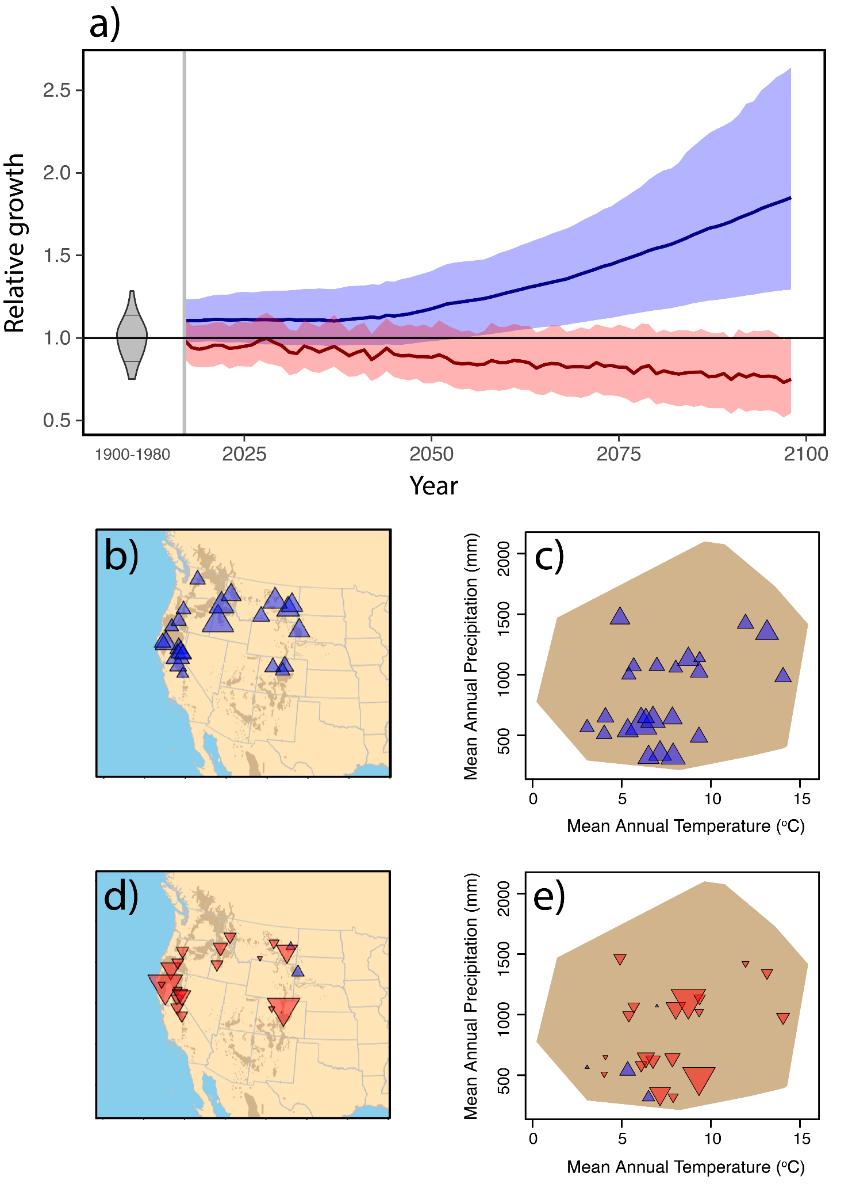**Figure 5.**  Projected tree growth in an RCP 8.5 emissions scenario through the end of the 21st century, relative to 1900-1980 mean growth rates. The blue line in **(a)** indicates the median projected growth across all sites according to the species-wide climate response. The red line indicates the same according to population-specific climate responses, with blue and red shading indicating 95% credible intervals. The gray density plot (1900-1980) indicates the distribution of median growth rates used in model fitting, averaged across trees and years in a site. **(b)** and **(c)** show the mean predicted relative growth according to the species-wide response in the last quarter-century of the prediction period (2075-2099) by site, in geographic space and climatic niche space, respectively. **(d)** and **(e)** show the same for population-specific responses. In panels **(b)** – **(e)**, blue triangles indicate relative growth rates greater than one, red triangles indicate rates less than one, and symbol size is scaled proportionally to the magnitude of the mean prediction.

**References**

Abatzoglou, J. T., Dobrowski, S. Z., & Parks, S. A. (2020). Multivariate climate departures have outpaced univariate changes across global lands. *Scientific Reports*, *10*(1), 1–9. https://doi.org/10.1038/s41598-020-60270-5

Abatzoglou, J. T., & Williams, A. P. (2016). Impact of anthropogenic climate change on wildfire across western US forests. *Proceedings of the National Academy of Sciences of the United States of America*, *113*(42), 11770–11775. https://doi.org/10.1073/pnas.1607171113

Adler, P. B., White, E. P., & Cortez, M. H. (2020). Matching the forecast horizon with the relevant spatial and temporal processes and data sources. *Ecography*, *43*, 1729–1739. https://doi.org/10.1111/ecog.04083

Aitken, S. N., & Bemmels, J. B. (2016). Time to get moving: Assisted gene flow of forest trees. *Evolutionary Applications*, *9*(1), 271–290. https://doi.org/10.1111/eva.12293

Alberto, F. J., Aitken, S. N., Alía, R., González-Martínez, S. C., Hänninen, H., Kremer, A., … Savolainen, O. (2013). Potential for evolutionary responses to climate change - evidence from tree populations. *Global Change Biology*, *19*(6), 1645–1661. https://doi.org/10.1111/gcb.12181

Anderegg, L. D. L., & HilleRisLambers, J. (2019). Local range boundaries vs. large-scale trade-offs: climatic and competitive constraints on tree growth. *Ecology Letters*. https://doi.org/10.1111/ele.13236

Angert, A. L., Sheth, S. N., & Paul, J. R. (2011). Incorporating population-level variation in thermal performance into predictions of geographic range shifts. *Integrative and Comparative Biology*, *51*(5), 733–750. https://doi.org/10.1093/icb/icr048

Araújo, M. B., Anderson, R. P., Barbosa, A. M., Beale, C. M., Dormann, C. F., Early, R., … Rahbek, C. (2019). Standards for distribution models in biodiversity assessments. *Science Advances*, *5*(1), 1–12. https://doi.org/10.1126/sciadv.aat4858

Araújo, M. B., Thuiller, W., & Yoccoz, N. G. (2009). Reopening the climate envelope reveals macroscale associations with climate in European birds. *Proceedings of the National Academy of Sciences of the United States of America*, *106*(16), 45–46. https://doi.org/10.1073/pnas.0813294106

Astigarraga, J., Andivia, E., Zavala, M. A., Gazol, A., Cruz-Alonso, V., Vicente-Serrano, S. M., & Ruiz-Benito, P. (2020). Evidence of non-stationary relationships between climate and forest responses: Increased sensitivity to climate change in Iberian forests. *Global Change Biology*, *26*(9), 5063–5076. https://doi.org/10.1111/gcb.15198

Babst, F., Bodesheim, P., Charney, N., Friend, A. D., Girardin, M. P., Klesse, S., … Evans, M. E. K. (2018). When tree rings go global : Challenges and opportunities for retro- and prospective insight. *Quaternary Science Reviews*, *197*, 1–20. https://doi.org/10.1016/j.quascirev.2018.07.009

Baer, K. C., & Maron, J. L. (2020). Ecological niche models display nonlinear relationships with abundance and demographic performance across the latitudinal distribution of Astragalus utahensis (Fabaceae). *Ecology and Evolution*, *10*(15), 8251–8264. https://doi.org/10.1002/ece3.6532

Beale, C. M., Lennon, J. J., & Gimona, A. (2008). Opening the climate envelope reveals no macroscale associations with climate in European birds. *Proceedings of the National Academy of Sciences of the United States of America*, *105*(39), 14908–14912. https://doi.org/10.1073/pnas.0803506105

Benito Garzón, M., Robson, T. M., & Hampe, A. (2019). ΔTraitSDMs: species distribution models that account for local adaptation and phenotypic plasticity. *New Phytologist*, *222*(4), 1757–1765. https://doi.org/10.1111/nph.15716

Bunn, A. G. (2010). Statistical and visual crossdating in R using the dplR library. *Dendrochronologia*, *28*(4), 251–258. https://doi.org/10.1016/j.dendro.2009.12.001

Bunn, A. G. (2008). A dendrochronology program library in R (dplR). *Dendrochronologia*, *26*(2), 115–124. https://doi.org/10.1016/j.dendro.2008.01.002

Bunn, A. G. (2010). Statistical and visual crossdating in R using the dplR library. *Dendrochronologia*, *28*(4), 251–258. https://doi.org/10.1016/j.dendro.2009.12.001

Bürkner, P. C. (2018). Advanced Bayesian multilevel modeling with the R package brms. *R Journal*, *10*(1), 395–411. https://doi.org/10.32614/rj-2018-017

Callaham, R. (1962). Geographic variability in growth of forest trees. In T. T. Kozlowski (Ed.), *Tree Growth* (pp. 311–325). The Ronald Press Company. Retrieved from http://www.treesearch.fs.fed.us/pubs/32866

Canham, C. D., Murphy, L., Riemann, R., McCullough, R., & Burrill, E. (2018). Local differentiation in tree growth responses to climate. *Ecosphere*, *9*(8), e02368. https://doi.org/10.1002/ecs2.2368

Carroll, C. J. W., Knapp, A. K., & Martin, P. H. (2021). Higher temperatures increase growth rates of Rocky Mountain montane tree seedlings. *Ecosphere*, *12*(3). https://doi.org/10.1002/ecs2.3414

Chardon, N. I., Pironon, S., Peterson, M. L., & Doak, D. F. (2020). Incorporating intraspecific variation into species distribution models improves distribution predictions, but cannot predict species traits for a wide-spread plant species. *Ecography*, *43*(1), 60–74. https://doi.org/10.1111/ecog.04630

Charney, N. D., Babst, F., Poulter, B., Record, S., Trouet, V. M., Frank, D., … Evans, M. E. K. (2016). Observed forest sensitivity to climate implies large changes in 21st century North American forest growth. *Ecology Letters*, *19*(9), 1119–1128. https://doi.org/10.1111/ele.12650

Chen, P. Y., Welsh, C., & Hamann, A. (2010). Geographic variation in growth response of Douglas-fir to interannual climate variability and projected climate change. *Global Change Biology*, *16*(12), 3374–3385. https://doi.org/10.1111/j.1365-2486.2010.02166.x

Clark, J. S., Andrus, R., Aubry-kientz, M., Bergeron, Y., Bogdziewicz, M., Bragg, D. C., … Zhu, K. (2021). Continent-wide tree fecundity driven by indirect climate effects. *Nature Communications*, *12*(1242), 1–11. https://doi.org/10.1038/s41467-020-20836-3

Collart, F., Hedenäs, L., Broennimann, O., Guisan, A., & Vanderpoorten, A. (2021). Intraspecific differentiation: Implications for niche and distribution modelling. *Journal of Biogeography*, *48*(2), 415–426. https://doi.org/10.1111/jbi.14009

Cook, E. R. (1987). The Decomposition of Tree-Ring Series for Environmental Studies. *Tree-Ring Bulletin*, *47*, 37–59.

Dallas, T. A., & Hastings, A. (2018). Habitat suitability estimated by niche models is largely unrelated to species abundance. *Global Ecology and Biogeography*, *27*(12), 1448–1456. https://doi.org/10.1111/geb.12820

Dobrowski, S. Z., Abatzoglou, J., Swanson, A. K., Greenberg, J. A., Mynsberge, A. R., Holden, Z. A., & Schwartz, M. K. (2013). The climate velocity of the contiguous United States during the 20th century. *Global Change Biology*, *19*(1), 241–251. https://doi.org/10.1111/gcb.12026

Drobyshev, I., Övergaard, R., Saygin, I., Niklasson, M., Hickler, T., Karlsson, M., & Sykes, M. T. (2010). Masting behaviour and dendrochronology of European beech (Fagus sylvatica L.) in southern Sweden. *Forest Ecology and Management*, *259*(11), 2160–2171. https://doi.org/10.1016/j.foreco.2010.01.037

Duarte, C. M. (2014). Global change and the future ocean: A grand challenge for marine sciences. *Frontiers in Marine Science*, *1*(DEC), 1–16. https://doi.org/10.3389/fmars.2014.00063

Enright, N. J., Fontaine, J. B., Bowman, D. M. J. S., Bradstock, R. A., & Williams, R. J. (2015). Interval squeeze: Altered fire regimes and demographic responses interact to threaten woody species persistence as climate changes. *Frontiers in Ecology and the Environment*, *13*(5), 265–272. https://doi.org/10.1890/140231

Evans, M. E. K., Black, B. A., Falk, D. A., Giebink, C. L., & Schultz, E. L. (2021). Growth rings across the Tree of LIfe: demographic insights from biogenic time series data. In *Demographic Methods Across the Tree of Life* (p. 77). Oxford University Press.

Farjon, A., & Filer, D. (2013). *An Atlas of the World’s Conifers*. Leiden, The Netherlands: Koninklijke Brill.

Felton, A. J., Shriver, R. K., Stemkovski, M., Bradford, J. B., Suding, K. N., & Adler, P. B. (2021). The rate of ecological acclimation is the dominant uncertainty in long-term projections of a key ecosystem service. *BioRxiv*, 2021.08.11.455579. Retrieved from http://biorxiv.org/content/early/2021/08/12/2021.08.11.455579.abstract

Fries, A., Lindgren, D., Ying, C. C., & Ruotsalainen, S. (2000). The effect of temperature on site index in western Canada and Scandinavia estimated from IUFRO Pinus contorta provenance experiments. *Canadian Journal of Forest Research*, *30*, 921–929.

Garrett, K. A., Nita, M., Wolf, E. D. D., Gomez, L., & Sparks, A. H. (2009). *Plant Pathogens as Indicators of Climate Change*. *Climate Change* (1st ed.). Elsevier B.V. https://doi.org/10.1016/B978-0-444-53301-2.00025-7

Gelman, A., Goodrich, B., Gabry, J., & Vehtari, A. (2019). R-squared for Bayesian Regression Models. *American Statistician*, *73*(3), 307–309. https://doi.org/10.1080/00031305.2018.1549100

Green, R. E., Collingham, Y. C., Willis, S. G., Gregory, R. D., Smith, K. W., & Huntley, B. (2008). Performance of climate envelope models in retrodicting recent changes in bird population size from observed climatic change. *Biology Letters*, *4*(5), 599–602. https://doi.org/10.1098/rsbl.2008.0052

Hacket-Pain, A. J., Friend, A. D., Lageard, J. G. A., & Thomas, P. A. (2015). The influence of masting phenomenon on growth-climate relationships in trees: Explaining the influence of previous summers’ climate on ring width. *Tree Physiology*, *35*(3), 319–330. https://doi.org/10.1093/treephys/tpv007

Herrando-Pérez, S., Ferri-Yáñez, F., Monasterio, C., Beukema, W., Gomes, V., Belliure, J., … Araújo, M. B. (2019). Intraspecific variation in lizard heat tolerance alters estimates of climate impact. *Journal of Animal Ecology*, *88*(2), 247–257. https://doi.org/10.1111/1365-2656.12914

Holt, R. D. (2020). Reflections on niches and numbers. *Ecography*, *43*(3), 387–390. https://doi.org/10.1111/ecog.04828

Jiménez-Valverde, A., Aragón, P., & Lobo, J. M. (2021). Deconstructing the abundance–suitability relationship in species distribution modelling. *Global Ecology and Biogeography*, *30*(1), 327–338. https://doi.org/10.1111/geb.13204

Kawecki, T. J., & Ebert, D. (2004). Conceptual issues in local adaptation. *Ecology Letters*, *7*(12), 1225–1241. https://doi.org/10.1111/j.1461-0248.2004.00684.x

Keen, R. M., Voelker, S. L., Wang, S. ‐Y. S., Bentz, B. J., Goulden, M., Dangerfield, C. R., … Still, C. J. (2021). Changes in tree drought sensitivity provided early warning signals to the California drought and forest mortality event. *Global Change Biology*, (August), 1–14. https://doi.org/10.1111/gcb.15973

Klesse, S., Derose, R. J., Guiterman, C. H., Lynch, A. M., Connor, C. D. O., Shaw, J. D., & Evans, M. E. K. (2018). Sampling bias overestimates climate change impacts on forest growth in the southwestern United States. *Nature Communications*, (2018), 1–9. https://doi.org/10.1038/s41467-018-07800-y

Klesse, S., DeRose, R. J., Babst, F., Black, B. A., Anderegg, L. D. L., Axelson, J., … Evans, M. E. K. (2020). Continental-scale tree-ring-based projection of Douglas-fir growth: Testing the limits of space-for-time substitution. *Global Change Biology*, *26*(9), 5146–5163. https://doi.org/10.1111/gcb.15170

Kunstler, G., Guyennon, A., Ratcliffe, S., Rüger, N., Ruiz-Benito, P., Childs, D. Z., … Salguero-Gomez, R. (2020). Demographic performance of European tree species at their hot and cold climatic edges. *Journal of Ecology*, (January), 1–14. https://doi.org/10.1111/1365-2745.13533

Langlet, O. (1971). Two hundred years of genecology. *Taxon1*, *20*(5/6), 653–721.

Lenoir, J., & Svenning, J. C. (2015). Climate-related range shifts - a global multidimensional synthesis and new research directions. *Ecography*, *38*(1), 15–28. https://doi.org/10.1111/ecog.00967

Lenoir, J., Bertrand, R., Comte, L., Bourgeaud, L., Hattab, T., Murienne, J., & Grenouillet, G. (2020). Species better track climate warming in the oceans than on land. *Nature Ecology & Evolution*. https://doi.org/10.1038/s41559-020-1198-2

Lessard, V. C., Drummer, T. D., & Reed, D. D. (2002). Precision of density estimates from fixed-radius plots compared to n-tree distance sampling. *Forest Science*, *48*(1), 1–6. https://doi.org/10.1519/JSC.0b013e3181f1598c

Littlefield, C. E., Dobrowski, S. Z., Abatzoglou, J. T., Parks, S. A., & Davis, K. T. (2020). A climatic dipole drives short- and long-term patterns of postfire forest recovery in the western United States, 1–8. https://doi.org/10.1073/pnas.2007434117

Maguire, B. (1973). Niche Response Structure and the Analytical Potentials of Its Relationship to the Habitat. *The American Naturalist*, *107*(954), 213–246.

Maguire, K. C., Shinneman, D. J., Potter, K. M., & Hipkins, V. D. (2018). Intraspecific niche models for ponderosa pine (Pinus ponderosa) suggest potential variability in population-level response to climate change. *Systematic Biology*, *67*(6), 958–978. https://doi.org/10.1093/sysbio/syy017

McCullough, I. M., Davis, F. W., & Williams, A. P. (2017). A range of possibilities: Assessing geographic variation in climate sensitivity of ponderosa pine using tree rings. *Forest Ecology and Management*, *402*, 223–233. https://doi.org/10.1016/j.foreco.2017.07.025

McGill, B. J. (2012). Trees are rarely most abundant where they grow best. *Journal of Plant Ecology*, *5*(1), 46–51. https://doi.org/10.1093/jpe/rtr036

McGill, B. J., Enquist, B. J., Weiher, E., & Westoby, M. (2006). Rebuilding community ecology from functional traits. *Trends in Ecology and Evolution*, *21*(4), 178–185. https://doi.org/10.1016/j.tree.2006.02.002

Midolo, G., Wellstein, C., & Faurby, S. (2021). Individual fitness is decoupled from coarse-scale probability of occurrence in North American trees. *Ecography*, *44*, 789–801. https://doi.org/10.1111/ecog.04083

Moran, E. V. (2020). Simulating the effects of local adaptation and life history on the ability of plants to track climate shifts. *AoB PLANTS*, *12*(1), 1–11. https://doi.org/10.1093/aobpla/plaa008

Muggeo, V. M. R. (2017). Interval estimation for the breakpoint in segmented regression: a smoothed score-based approach. *Australian and New Zealand Journal of Statistics*, *59*(3), 311–322. https://doi.org/10.1111/anzs.12200

O’neill, G. A., & Gómez-Pineda, E. (2021). Local was best: Sourcing tree seed for future climates. *Canadian Journal of Forest Research*, *51*(10), 1432–1439. https://doi.org/10.1139/cjfr-2020-0408

Osorio‐Olvera, L., Soberón, J., & Falconi, M. (2019). On population abundance and niche structure. *Ecography*, *42*(8), 1415–1425. https://doi.org/10.1111/ecog.04442

Pan, Y., Birdsey, R. A., Fang, J., Houghton, R., Kauppi, P. E., Kurz, W. A., … Hayes, D. (2011). A large and persistent carbon sink in the world’s forests. *Science*, *333*(6045), 988–993. https://doi.org/10.1126/science.1201609

Pelini, S. L., Dzurisin, J. D. K., Prior, K. M., Williams, C. M., Marsico, T. D., Sinclair, B. J., & Hellmann, J. J. (2009). Translocation experiments with butterflies reveal limits to enhancement of poleward populations under climate change. *Proceedings of the National Academy of Sciences of the United States of America*, *106*(27), 11160–11165. https://doi.org/10.1073/pnas.0900284106

Peltier, D. M. P., & Ogle, K. (2020). Tree growth sensitivity to climate is temporally variable. *Ecology Letters*, *23*(11), 1561–1572. https://doi.org/10.1111/ele.13575

Perret, D. L., Leslie, A. B., & Sax, D. F. (2019). Naturalized distributions show that climatic disequilibrium is structured by niche size in pines ( Pinus L .). *Global Ecology and Biogeography*, *28*(4), 429–441. https://doi.org/10.1111/geb.12862

Perret, D. L., & Sax, D. F. (2021). Evaluating alternative study designs for optimal sampling of species’ climatic niches. *Ecography*, 1–12. https://doi.org/10.1111/ecog.06014

Peterson, M. L., Doak, D. F., & Morris, W. F. (2019). Incorporating local adaptation into forecasts of species’ distribution and abundance under climate change. *Global Change Biology*, (September 2018), 775–793. https://doi.org/10.1111/gcb.14562

Phipps, R. L. (2005). Some geometric constraints on ring-width trend. *Tree-Ring Research*, *61*(2), 73–76. https://doi.org/10.3959/1536-1098-61.2.73

Piovesan, G., & Biondi, F. (2021). On tree longevity. *New Phytologist*, *231*(4), 1318–1337. https://doi.org/10.1111/nph.17148

Prasad, A., & Leites, L. (2021). Ecological analysis of intraspecific variability of eastern white pine (Pinus strobus) under climate change by combining provenance and demographic data. *Landscape Ecology*, *4*. https://doi.org/10.1007/s10980-021-01333-4

Renwick, K. M., Curtis, C., Kleinhesselink, A. R., Schlaepfer, D., Bradley, B. A., Aldridge, C. L., … Adler, P. B. (2018). Multi-model comparison highlights consistency in predicted effect of warming on a semi-arid shrub. *Global Change Biology*, *24*(1), 424–438. https://doi.org/10.1111/gcb.13900

Restaino, C. M., Peterson, D. L., & Littell, J. (2016). Increased water deficit decreases Douglas fir growth throughout western US forests. *Proceedings of the National Academy of Sciences*, *113*(34), 9557–9562. https://doi.org/10.1073/pnas.1602384113

Rollinson, C. R., Alexander, M. R., Dye, A. W., Moore, D. J. P., Pederson, N., & Trouet, V. (2021). Climate sensitivity of understory trees differs from overstory trees in temperate mesic forests. *Ecology*, *102*(3), 1–11. https://doi.org/10.1002/ecy.3264

Santini, L., Pironon, S., Maiorano, L., & Thuiller, W. (2019). Addressing common pitfalls does not provide more support to geographical and ecological abundant-centre hypotheses. *Ecography*, *42*(4), 696–705. https://doi.org/10.1111/ecog.04027

Savolainen, O., Pyhäjärvi, T., & Knürr, T. (2007). Gene flow and local adaptation in trees. *Annual Review of Ecology, Evolution, and Systematics*, *38*, 595–619. https://doi.org/10.1146/annurev.ecolsys.38.091206.095646

Schultz, E. L., Hulsmann, L., Pillet, M. D., Hartig, F., D., B. D., Record, S., … Evans, M. E. K. (2021). Climate-driven, but dynamic and complex? A reconciliation of competing hypotheses for species’ distributions. *Ecology Letters*, *in press*.

Sebastian-Azcona, J., Hamann, A., Hacke, U. G., & Rweyongeza, D. (2019). Survival, growth and cold hardiness tradeoffs in white spruce populations: Implications for assisted migration. *Forest Ecology and Management*, *433*(November 2018), 544–552. https://doi.org/10.1016/j.foreco.2018.10.046

Skinner, W. R., & Majorowicz, J. A. (1999). Regional climatic warming and associated twentieth century land-cover changes in north-western North America. *Climate Research*, *12*, 39–52.

Sork, V. L., Aitken, S. N., Dyer, R. J., Eckert, A. J., Legendre, P., & Neale, D. B. (2013). Putting the landscape into the genomics of trees: Approaches for understanding local adaptation and population responses to changing climate. *Tree Genetics and Genomes*, *9*(4), 901–911. https://doi.org/10.1007/s11295-013-0596-x

Speer, J. H. (2012). *Fundamentals of Tree-Ring Research*. Tucson: University of Arizona Press.

Srivastava, D. S., Coristine, L., Angert, A. L., Bontrager, M., Amundrud, S. L., Williams, J. L., … Donner, S. D. (2021). Wildcards in climate change biology. *Ecological Monographs*, *91*(4), 1–23. https://doi.org/10.1002/ecm.1471

Trouet, V., Babst, F., & Meko, M. (2018). Recent enhanced high-summer North Atlantic Jet variability emerges from three-century context. *Nature Communications*, *9*(1), 1–9. https://doi.org/10.1038/s41467-017-02699-3

Valladares, F., Matesanz, S., Guilhaumon, F., Araújo, M. B., Balaguer, L., Benito-Garzón, M., … Zavala, M. A. (2014). The effects of phenotypic plasticity and local adaptation on forecasts of species range shifts under climate change. *Ecology Letters*, *17*(11), 1351–1364. https://doi.org/10.1111/ele.12348

Van Nuland, M. E., Vincent, J. B., Ware, I. M., Mueller, L. O., Bayliss, S. L. J., Beals, K. K., … Bailey, J. K. (2020). Intraspecific trait variation across elevation predicts a widespread tree species’ climate niche and range limits. *Ecology and Evolution*, *10*(9), 3856–3867. https://doi.org/10.1002/ece3.5969

Veen, B. (1954). General remarks on provenance research in forestry. *Euphytica*, *3*, 89–96.

Willyard, A., Gernandt, D. S., López-Reyes, A., & Potter, K. M. (2021). Mitochondrial phylogeography of the ponderosa pines: widespread gene capture, interspecific sharing, and two unique lineages. *Tree Genetics & Genomes*, *17*(6), 1–19. https://doi.org/10.1007/s11295-021-01529-4

Willyard, A., Gernandt, D. S., Potter, K., Hipkins, V., Marquardt, P., Mahalovich, M. F., … Wofford, A. (2017). Pinus ponderosa: A checkered past obscured four species. *American Journal of Botany*, *104*(1), 161–181. https://doi.org/10.3732/ajb.1600336

Wilmking, M., Id, O., Buras, A., Id, O., Lange, J., & Id, O. (2020). Global assessment of relationships between climate and tree growth. *Global Change Biology*, *26*(October 2019), 15057. https://doi.org/10.1111/gcb.15057

Woodin, S. A., Hilbish, T. J., Helmuth, B., Jones, S. J., & Wethey, D. S. (2013). Climate change, species distribution models, and physiological performance metrics: Predicting when biogeographic models are likely to fail. *Ecology and Evolution*, *3*(10), 3334–3346. https://doi.org/10.1002/ece3.680

Zhao, S., Pederson, N., Orangeville, L. D., Hillerislambers, J., Boose, E., Penone, C., … Manzanedo, R. D. (2018). The International Tree‐Ring Data Bank ( ITRDB ) revisited: Data availability and global ecological representativity. *Journal of Biogeography*, 1–14. https://doi.org/10.1111/jbi.13488

**Supplementary Figures**

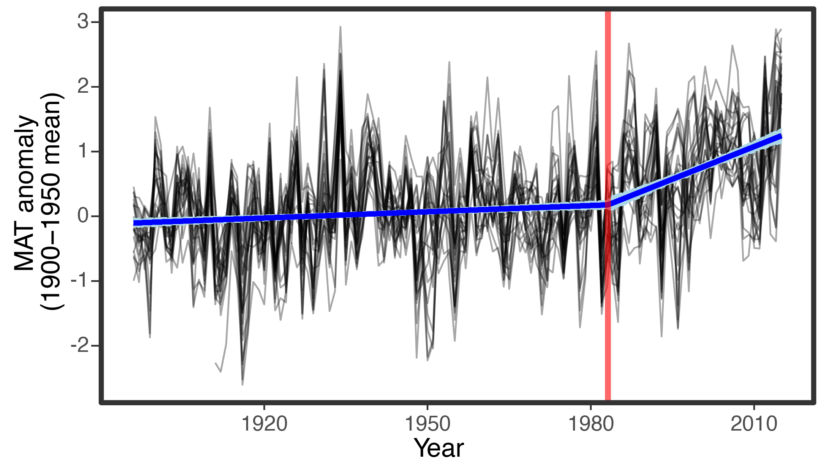

**Figure S1.** Mean annual temperature anomalies relative to the 1900-1950 mean across all study sites (black lines). Red vertical line indicates when the linear trend in the time series changes (1983), as identified by our breakpoint regression analysis. Blue line and shading show the estimated linear trend and 95% confidence interval before and after the breakpoint.

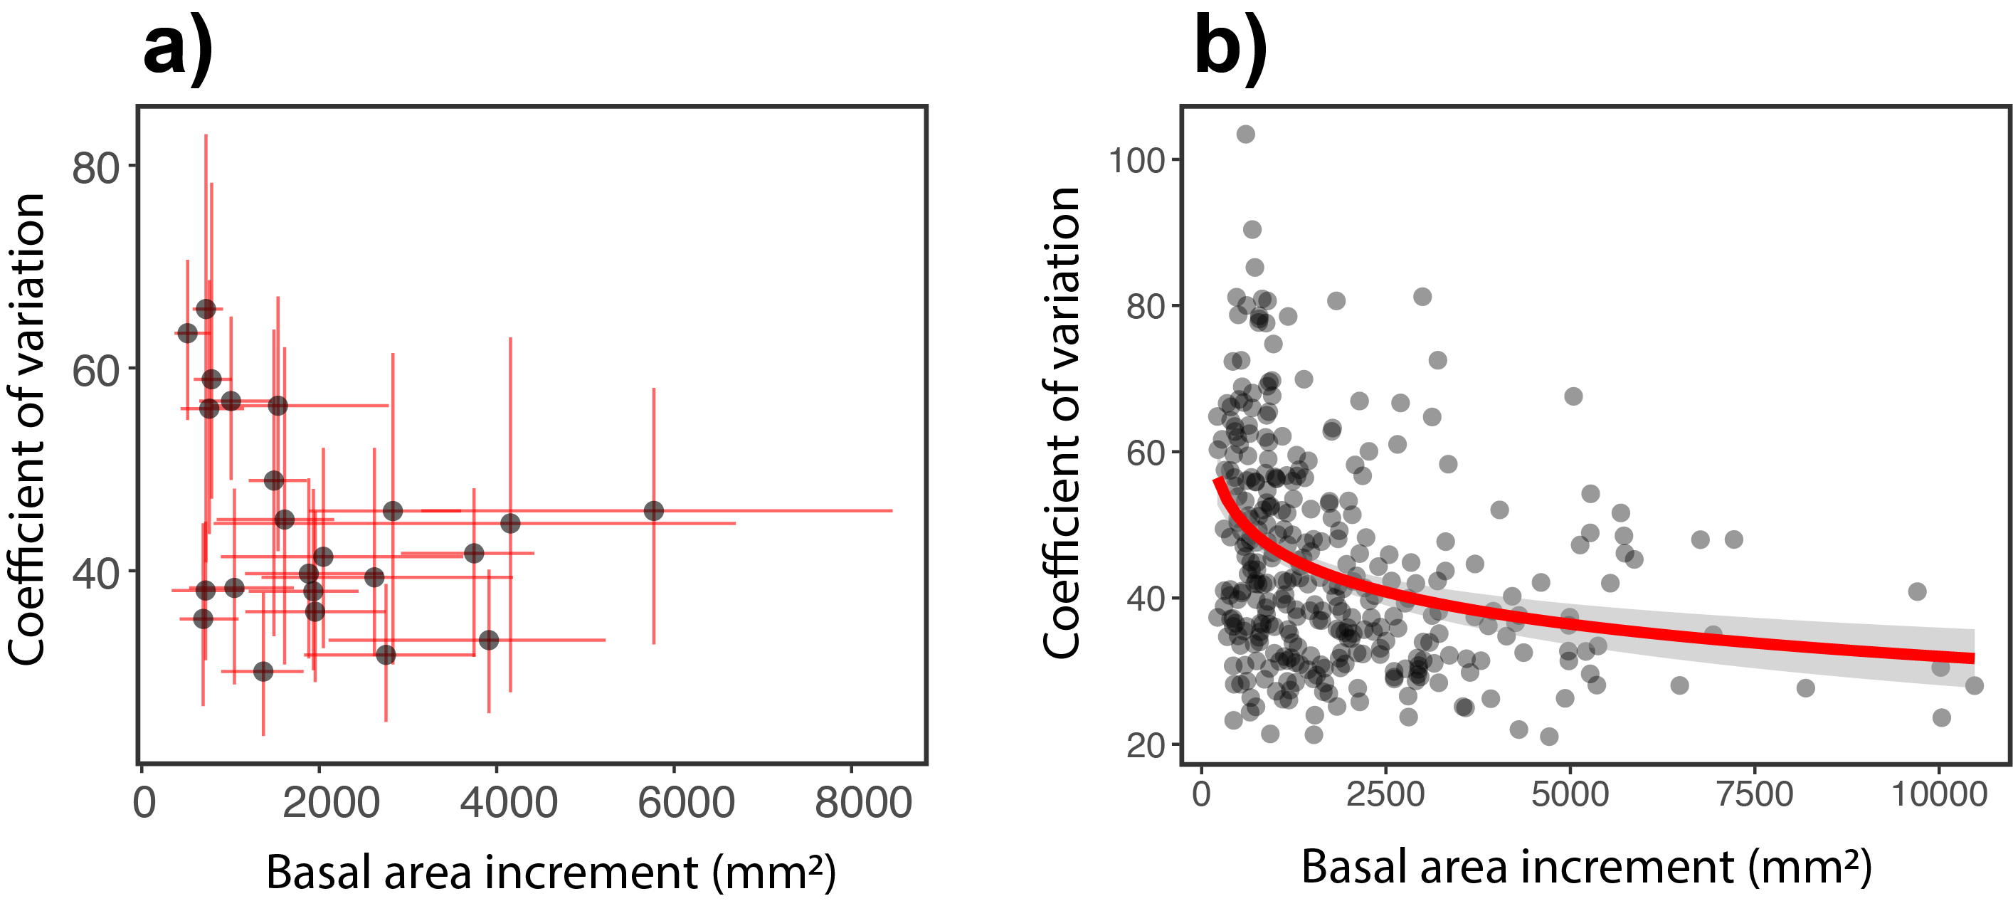

**Figure S2.** Relationship between growth rate (basal area increment) and the coefficient of variation (standard deviation expressed as a percentage of the mean; CV) within an annual growth time-series. Each point in panel **(a)** indicates the mean growth rate and CV across all trees in a site, with red lines showing the interquartile range within each site. Each point in panel **(b)** shows the mean growth rate and CV of an individual tree, with red line and shading showing a negative logistic regression and 95% confidence interval (R2=0.12, p < 0.001).

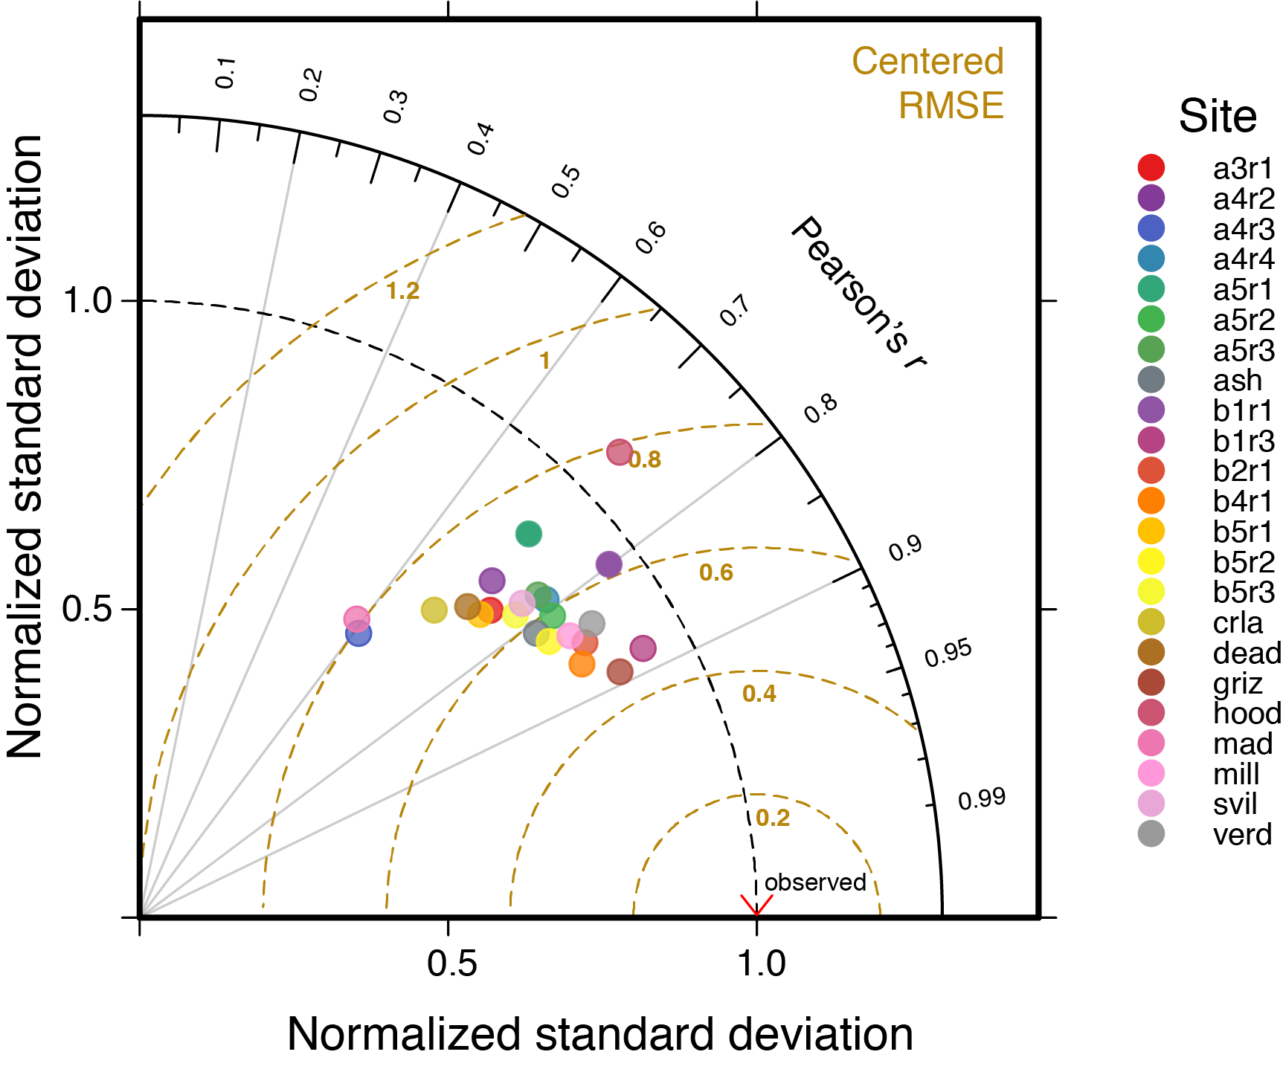

**Figure S3.** Taylor diagram showing how model fit varied between sites. Each colored point shows how fitted values from our growth model compared to observed growth, according to the normalized standard deviation (x and y axes), Pearson’s *r* (radial axis), and the centered root means squared error (distance from observed data point). The red chevron on the x-axis indicates the observed data (normalized standard deviation = 1; Pearson’s *r* = 1, RMSE = 0). Sites closer to the observed data have a better model fit than those further from the observed data. Site names are solely unique identifiers.

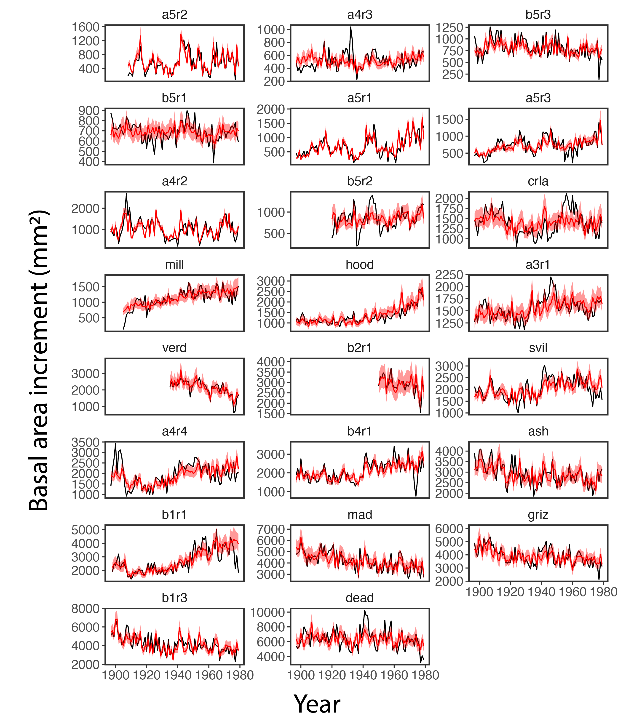**Figure S4.** Observed versus modeled growth chronologies in the pre-warming period for each study site. For each site (panels), the black line shows mean annual growth (basal area increment) across all trees in a site. The red line shows the mean posterior prediction from our growth model across all trees in a site, with red shading indicating the 95% credible interval. Sites are arranged in order of increasing mean growth rate from top left to bottom right.

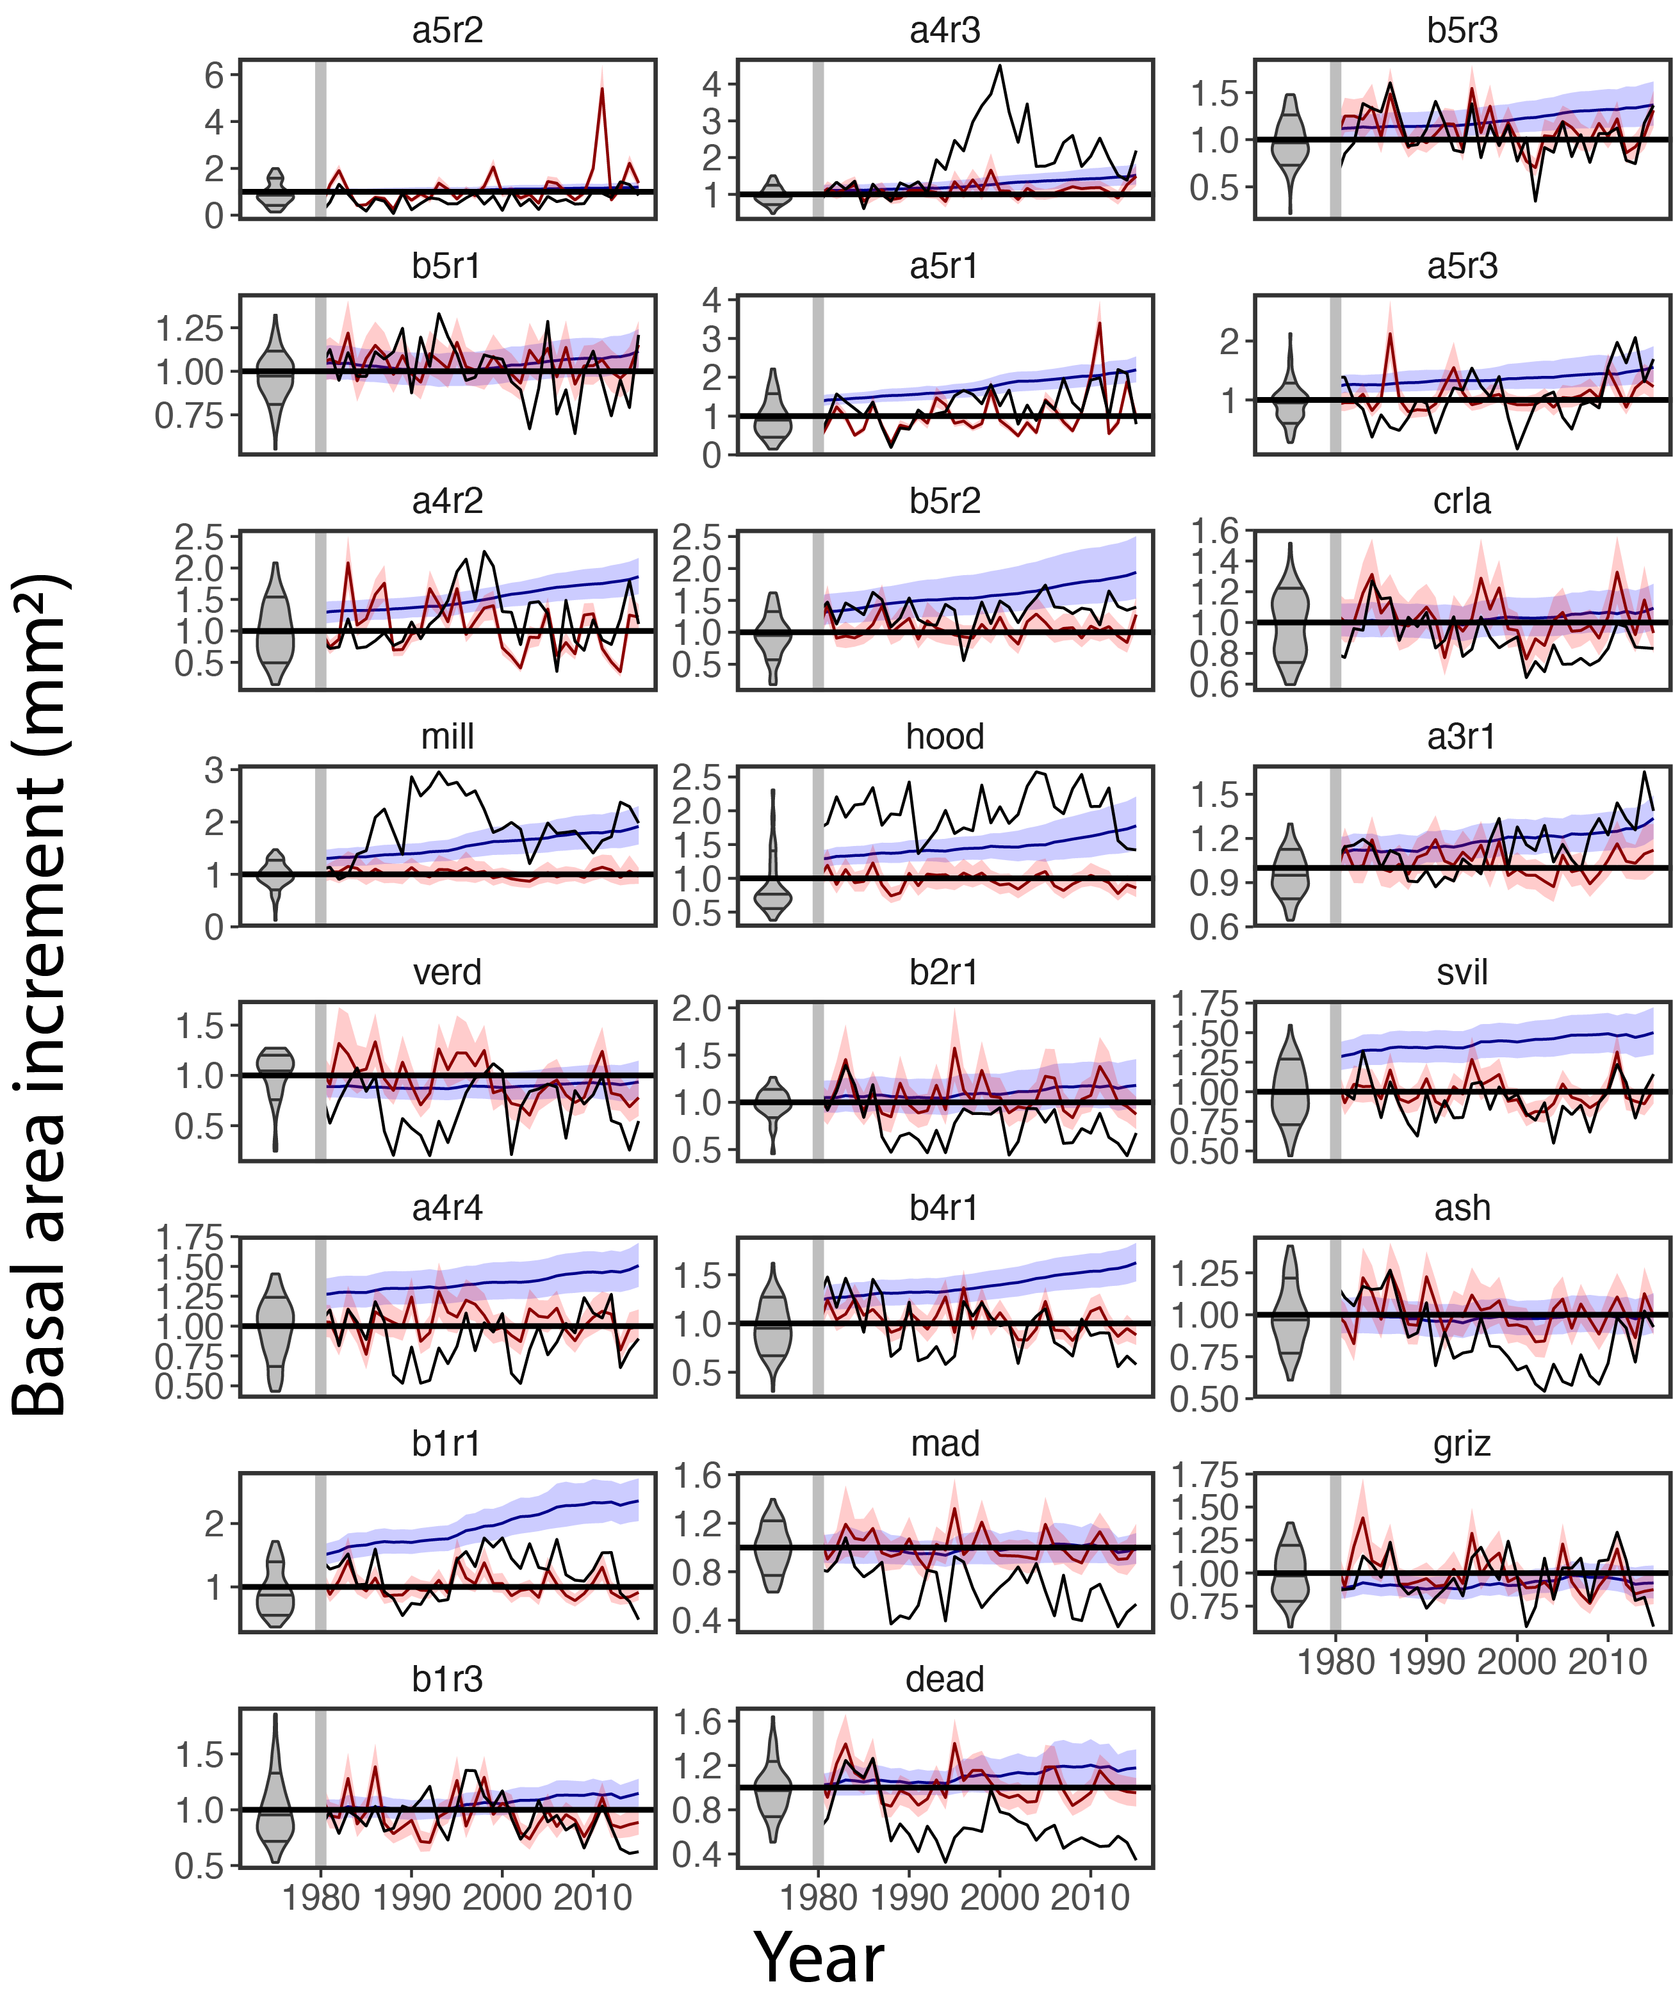

**Figure S5.** Comparisons of observed post-warming (1980-2015) growth to species-wide and population-specific growth predictions for each study site. For each site (panels), growth is shown relative to pre-1980 mean growth (y axes), with black lines showing observed mean growth. Blue lines and shading indicate species-wide predictions and 95% credible intervals, whereas red lines and shading show the same for population-specific predictions. Gray density plots on the left of each panel show the distribution of relative growth rates in the pre-warming period used to train the growth model. Sites are arranged in order of increasing mean growth rate from top left to bottom right. Figure 5 in the main text shows these results summarized across all sites.

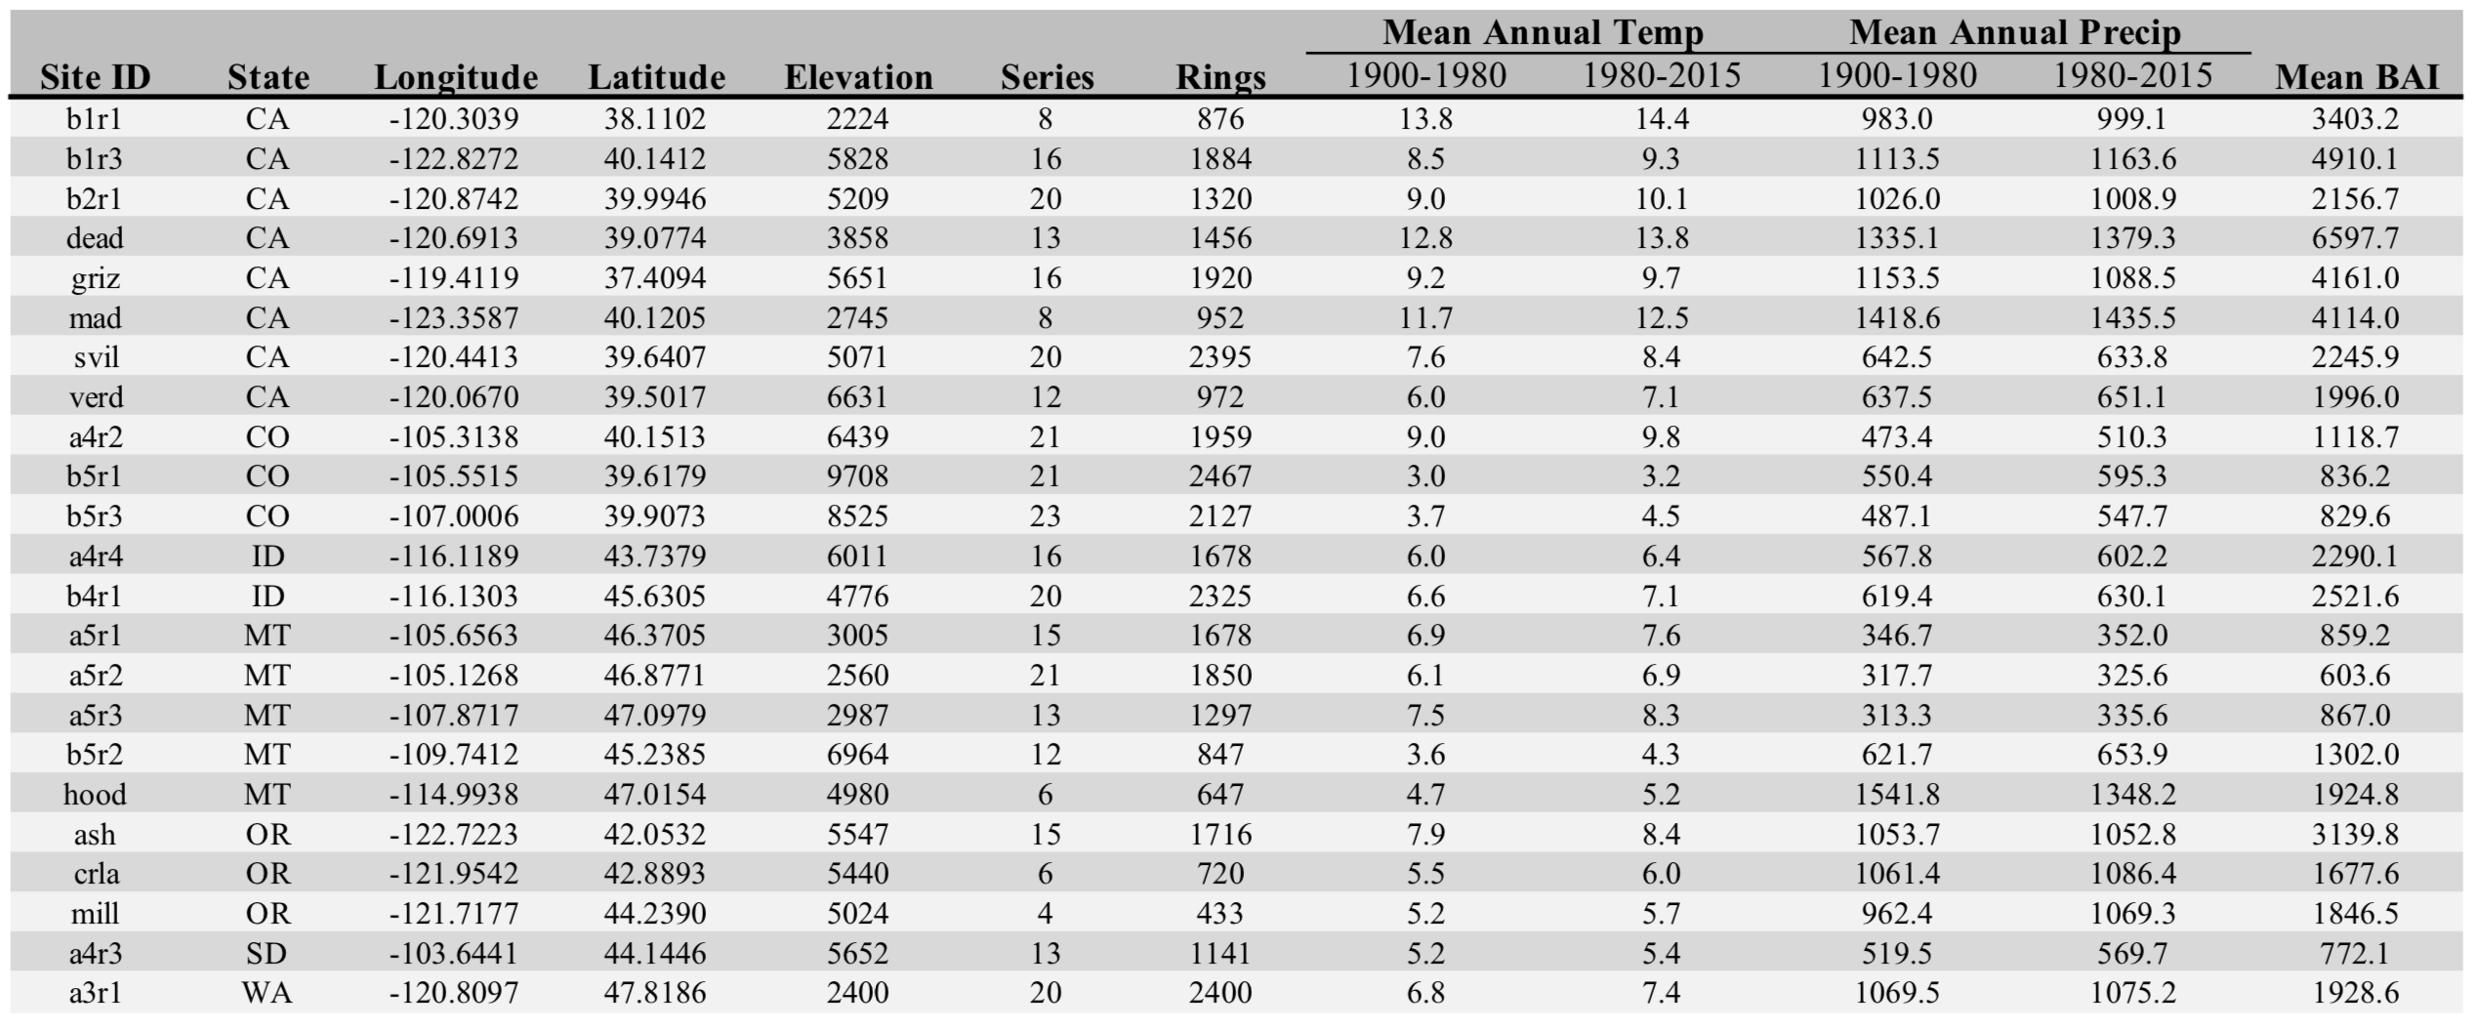

**Table S1** (preceding page). Study site locations and characteristics, including elevation (feet above sea level), number of growth time series (‘Series’), number of individual growth rings (‘Rings’), mean annual temperature (degrees Celsius) and precipitation (mm) in pre- and post-warming periods, and mean growth rate (basal area increment, mm2).